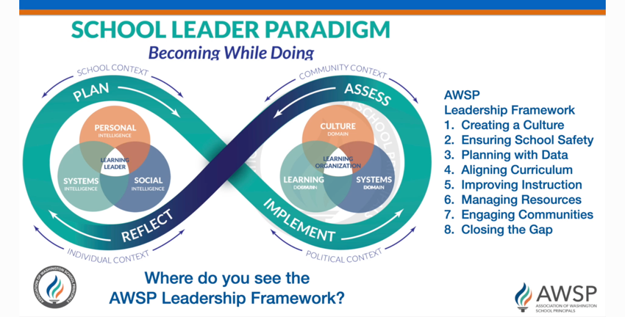

The School Leader Paradigm is NOT an evaluative tool. The School Leader Paradigm is a strong compliment to the AWSP Framework. It provides a visual, the space and indicators for school leaders to reflect on to continually become the best school leaders they can!

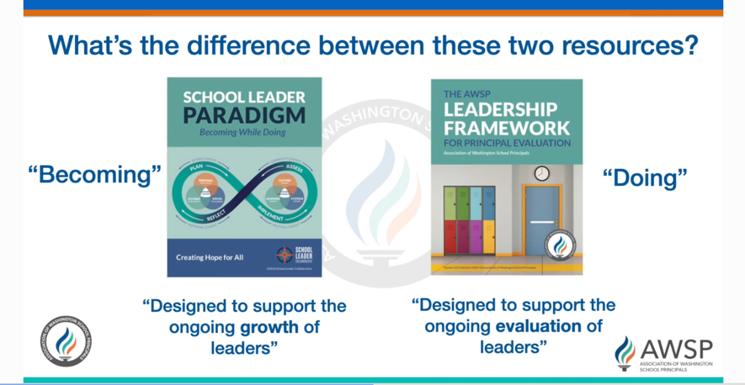

What’s the difference between these two resources?

What is the intent of each document? How should they be used?

How might you use each of these to support school leader GROWTH?

Could an example of unsuccessful leadership have been saved if the leader was more self-aware and reflective of both their strengths and weaknesses as a leader?

Final Thoughts!
What is the purpose of evaluation? Reflect on your past evaluation experiences…do they match up with what you have identified as the PURPOSE of evaluation?

