Taking an AHEAD elearning class in the PATH Learning Management System (LMS)
Typical classes will include one or more modules, each with Learning Objectives, Assignments and class Discussions. Many will include a videotaped or live presentation, with or without an accompanying reading assignment.
Example showing a Module that includes a video presentation, a survey to submit student bios, a pre-test and case study to read. Each segment of the module is linked to the previous one, so they show up as greyed-out text until the segment is completed.
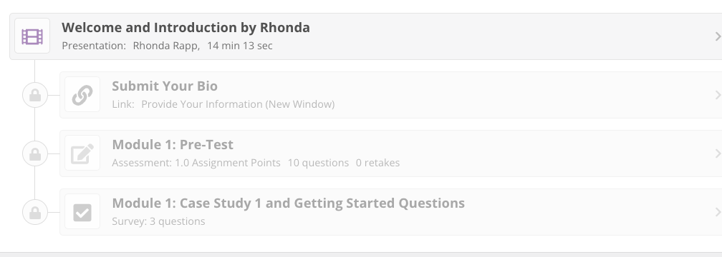
Video presentations will appear in a dedicated viewer and begin to play as it is downloaded (there might be a short lag time, depending on your internet connection). Videos are open-captioned. You can enlarge the video by clicking on the Expand icon on the bottom right of the video.
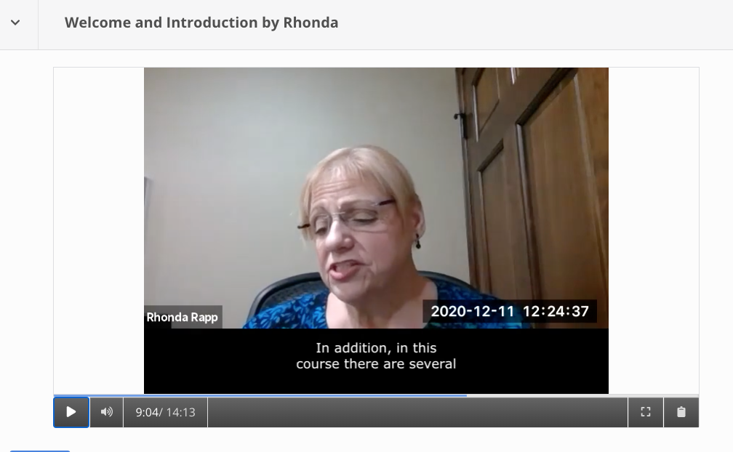
You can also type and download lecture notes within the video player if you’d like. The Notes icon for that is on the bottom-right of the videoplayer. The space for taking notes appears on the right of the player. The download button is a the bottom of the note-taking area.
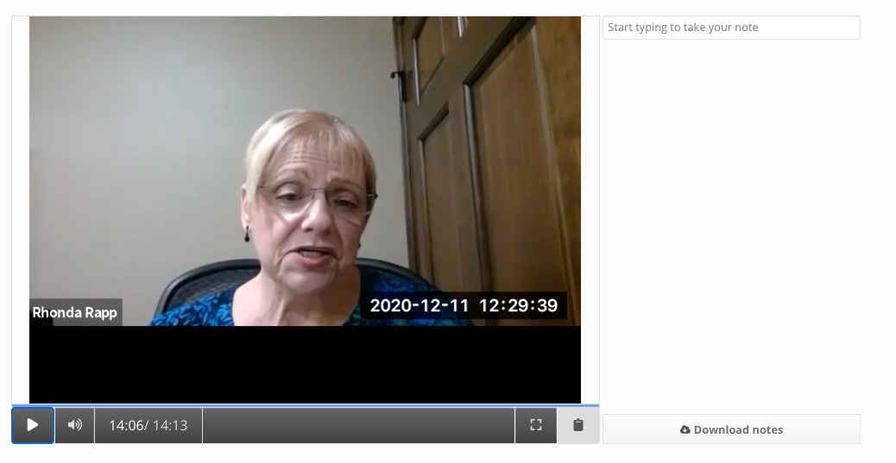
Live events will be offered via Zoom. Instructions for those will be available when that option is used.
Class Discussions appear at the bottom of each Module. The dates when discussions are available will appear in the heading above the Discussion space. For most discussions the instructor will suggest one or more questions for the class.
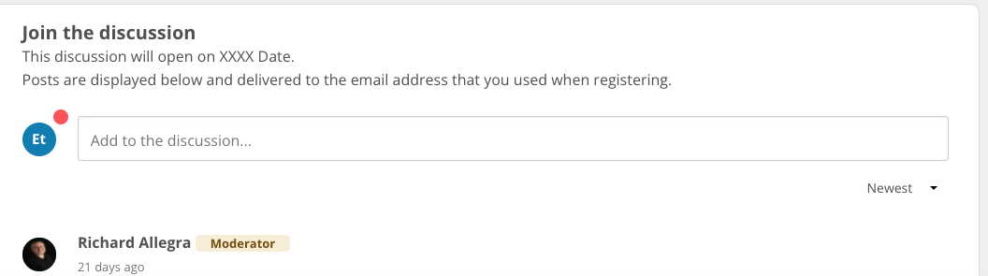

When you are done with one segment of the module a pop-up will appear that enables you to move on to the next component.
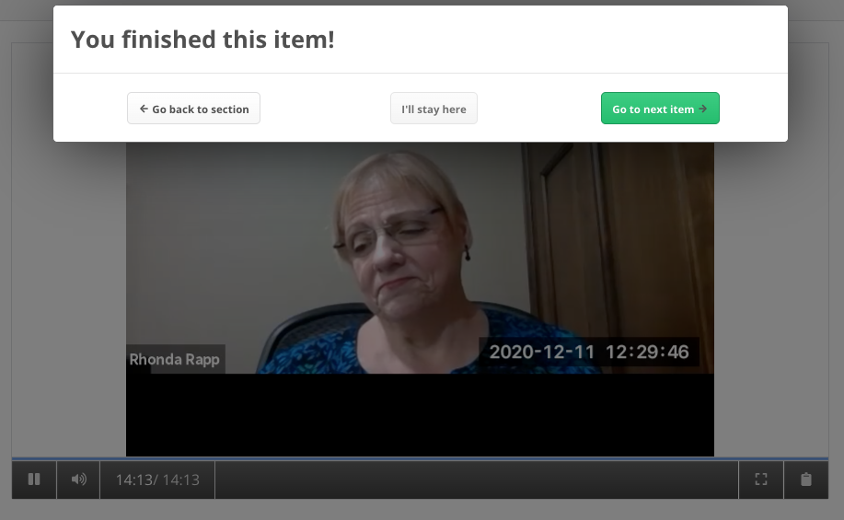

Certificates of Completion are available for AHEAD elearning classes. Instructions for obtaining them will be announced toward the end of each class. At this time the classes are not pre-approved for CEU’s by a licensing body, but you may be able to submit the certificate to your licensing or certification agency.

General tips for taking online classes
Treat an online class as you would an in-person class. Remember that you have paid for the class and chose it to add to your professional skills. Commit your time and attention as you would any other class.
Manage your time. Allot about 2 – 3 hours per week to listen (and maybe re-listen) to lectures; review notes; work on assignments.
Eliminate distractions. Adult Learners, especially, have a lot of things vying for their time – work, family, other commitments. Online classes are intangible. Find dedicated time and space to focus.
Think about your learning style & practices. You may prefer to work on your class first thing in the morning, or in the evening after family are settled. You might prefer to exercise or take a mental break before working on a weekly module or assignment.
Participate in discussions and group activities. Respond to instructor questions and discussion posts from other students. It helps to make what you are learning “stick.” Apply concepts to your work.

