Participant’s Guide

Episode 21

Communicating the Gospel Internationally

Summary

Jesus calls us to “Go, therefore, and make disciples of all nations…” (Matthew 28:19a, NASB), and His followers have, by God’s grace, succeeded in spreading the gospel throughout the world. This calling, however, comes with unique challenges. Respect for the differences between various cultures can enable us to communicate the universal need we all have for a Savior, and how the saving power of Jesus Christ can uniquely minister to the hearts of all.

Speaker
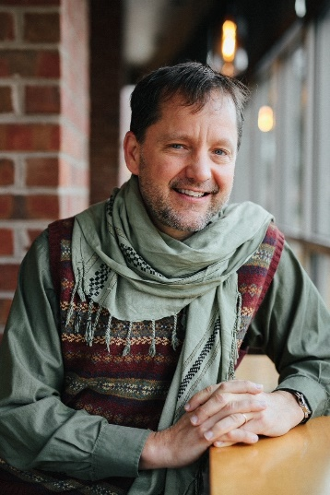
Dr. Scott trained at the Medical College of Virginia and Truman East Family Medicine Residency in Kansas City, Missouri. Dr. Scott and his family lived in South Asia from 1999 to 2015, providing medical care at a village mission hospital including a year and a half stint in a Gulf country where the security situation in South Asia worsened. Since 2015, Dr. Scott has taught family medicine at the Virginia Commonwealth University (VCU) School of Medicine and has worked part-time as CMDA staff at VCU. At the School of Medicine, he started the month-long International Medical Mission elective for senior students, during which he takes a group annually to Karanda Mission Hospital in Zimbabwe. He completed VCU’s TIME (Teaching in Medical Education) certificate course. He loves teaching and has received teaching awards in the Practice of Clinical Medicine program at VCU and from the Society of Teachers of Family Medicine. He is very keen on the professional, moral and spiritual formation of students, and he is eager to motivate and train them to serve internationally in cross-cultural contexts. He is active with the South Asian refugee and immigrant population in Richmond, Virginia. His wife JoAnn is an ESL teacher, and they have three grown sons. For further information or to contact Dr. Scott, email him at sarmistead123@gmail.com.

Discussion Questions

- What from this video inspired, edified or challenged you?

2. One of the biggest challenges for a missionary is that of contextualization—relating the gospel to a particular culture. Dr. Scott speaks of the challenge of sharing the gospel in an “honor-shame” culture. How might the gospel speak to an individual for whom personal honor and shame are dominating considerations?

3. We are told to “count the cost” of following Christ in Luke 14:27-32. What would be some of the costs of serving Christ in another culture?

4. Dr. Scott describes his efforts to “intentionally talk about my own weaknesses in the context of friendships” because it allowed him to become “a more safe person for people to reveal their struggles….”

- Why might this be hard for healthcare professionals to do?
- How could God use our transparency in the lives of our patients?
5. Westerners tend to see faith as a private matter, whereas in many parts of the world faith discussions are a normal part of life.
- Why might this be so?
- What adjustments could help a Westerner better fit in with those for whom spirituality is more integral to their conversations?
6. Dr. Cathie Scarbrough, having visited more than 30 countries to provide healthcare, concludes, “People are people, no matter where you go.” Despite the differences we encounter as we interact with those from other countries, what are some of the similarities that can give us confidence in sharing the love of Christ with them?
7. Dr. Trish Burgess tells of a patient unable to hear, who just needed her ears cleaned out: “I cleaned her ears, but God opened her ears to hear the gospel message.” Have you ever had a similar experience in your “mission field,” either domestically or internationally?
8. Jaime Saint exhorts short-term mission teams to recognize that “the physical is the best door to the spiritual” and empower the local church so “you can have a long-term impact on a short-term trip.” What are some ways mission teams can empower the local church before they head back home?
9. What is one take-home item from today’s session that you hope to implement?

Additional Resources

- Let the Nations Be Glad by John Piper
- Perspectives On The World Christian Movement, Third Edition edited by Ralph D. Winter and Steven C. Hawthorne

