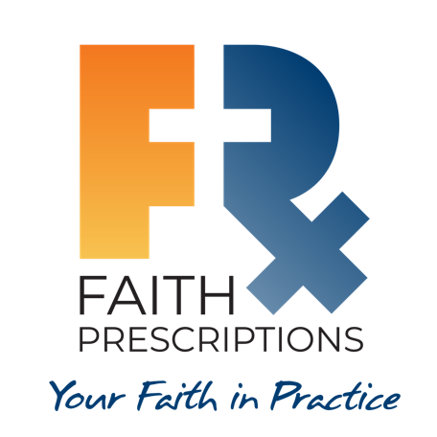
Leader’s Guide

Episode 2
The Case for Practicing Medicine Christianly – Part 1

Summary

Our identity in Christ is the foundation for our efforts to provide excellent care for our patients. Any attempt to artificially separate our faith from our professional lives will be detrimental to both our well-being and that of our patients. Our faith may make us a bit “different” from our colleagues, but this is a difference that God can use for His glory.

Speaker
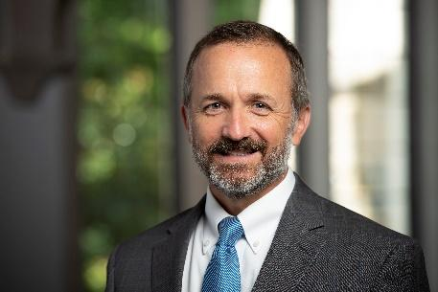
Farr Curlin, MD, is the Trent Professor of Medical Humanities and Co-Director of the Theology, Medicine, and Culture Initiative (TMC) at Duke University. Dr. Curlin’s ethics scholarship takes up moral questions that are raised by religion-associated differences in physicians’ practices. He is an active palliative medicine physician and holds appointments in both the School of Medicine and the Divinity School, where he and colleagues offer Christian theological formation to those with vocations to healthcare.

Discussion Questions

- What from this video inspired, edified or challenged you?

- Dr. Curlin explains the change in terminology that has occurred in our society’s reference to physicians as providers. How have you felt this distinction in your own practice? How do you react now that you’ve had the chance to think about it?

Our cultural shift towards consumerism has caused patients to view healthcare professionals as entities that exist to fulfill their every whim, rather than to help them on a path toward developing a healthy lifestyle. Another contributing factor is the unparalleled access patients have to medical information through the internet (both valid and dubious), which has lowered the public’s view of the expertise healthcare professionals were once revered for having. A third factor is that those in our society who choose to deny God will then proceed logically from this incorrect assumption to conclude there is no absolute morality, which reduces the issue of ethics to mere personal preference. As a result of these and other factors, many see healthcare professionals more as vending machines rather than as healthcare professionals.

One negative impact this change is having on our profession is the growing effort to “require” healthcare professionals to give patients what they want, even if it violates the healthcare professional’s conscience regarding what is best for them. CMDA is working hard to protect our right of conscience in fulfilling our responsibilities to God and to our patients. We in healthcare would be wise to change our terminology to better reflect God’s calling to serve our patients with professional judgment and integrity.

- If a Christian healthcare professional strives to separate their faith from their practice, how could this affect their:

  - quality of care?
  - tendency toward burnout?
  - calling into healthcare?

First, hopefully some will take exception to the wording of this question, because one cannot truly separate one’s faith from their life, and it would be good if this impossibility is recognized.

This discussion should really revolve around how destructive it can be for an individual to try to live up to the societal pressure to separate their faith from practice, rather than to live an integrated life in which their vocation is seen as a working out of their faith in practice.

  - Quality of care: The most basic calling of the Christian who finds themself in healthcare is to do good work, laboring wholeheartedly as unto the Lord rather than unto men (Colossians 3:23). By doing so, we will adorn the gospel and earn the respect of our patients and our peers.
  - Tendency toward burnout: That said, we must not live as though we were made for only work. We must reserve time for spiritual growth, Christian community and perhaps, if we are called, marriage, parenting and ministry opportunities.
  - Calling into healthcare: For many of us, our Christian faith played a tremendous role in us choosing to go into healthcare. We must learn to lean into that calling rather than diminish its importance in our lives.

This verse acknowledges the temptation to be more influenced by the worldly forces around us than by the God within us (John 14:16-17, Galatians 4:6). The combination of God’s Word and God’s Spirit are given to us so that we can “…take every thought captive to obey Christ” (2 Corinthians 10:5, ESV). The call of Christ on our lives it to be central, and it is to govern all other callings and influences.

- Consider Romans 12:2. How might we apply this verse to the perceived “secular-sacred” dichotomy?

Paul’s exhortation to not be conformed to this world, but to instead be transformed, illustrates the fact that there is a spiritual calling to deny the influence of worldliness in every undertaking. Any effort to deny the spiritual element of our lives in any endeavor will, by default, result in a tendency toward conformity with the ungodly influences of the world. There is no spiritually neutral state in which we can operate, personally or professionally, so even our pursuits that some would describe as “secular” are to be undertaken in accordance with God’s Word and by the power of the Holy Spirit. See also 1 John 4:4 and Romans 14:23.

- Dr. Curlin states, “Medicine is a human practice, and as a human practice is subject to distortion and corruption.” What could be preventing us from realizing this?

Those who possess a high level of knowledge are sometimes given an inflated level of respect, which can make their moral shortcomings less obvious. This dangerous tendency is referenced in 1 Corinthians 1:20-3, and it helps us to understand why scientific “advances” can be fraught with blatant immorality. We in science must be on guard with appropriate skepticism, asking not only, “Can we?” but first asking, “Should we?”

- How have you seen imperfections of humanity show up in your practice in a push to embrace progress?

As believers, we must develop discernment as we strive to navigate life as citizens of a different kingdom. Participants might raise several examples. At the time of writing for this leadership guide, the most prominent example in our day is the rapid cultural shift toward embracing complete affirmation for gender reassignment interventions as the only treatment for gender dysphoria. We must learn how to communicate our concerns about this issue, and others, with sincerity and compassion to avoid being labeled bigoted, hate filled or naïve.

- Dr. Curlin states, “I’ve talked to many Christians around the country in the past two decades in healthcare and heard them say things like, “You know, they would never allow one to do this,” or “You can’t do that,” or “You can’t say this,” or “This is not allowed.” And when I ask them, “Really? How do you know that?” It’s few of them who have actually tried to do the things they “know” they cannot do.”

Have you ever been reprimanded by an authority for spiritual interventions with patients? If so, what was your response?

As with many sources of fear, anticipation can quite often be far worse than the actuality of the situation. When appropriate principles of spiritual interventions are followed—showing sensitivity and respect and asking permission from the patient—it should be a very rare occurrence when trouble results. Much more will be said about this topic in future episodes.

- How can we be discerning when new information or technology is introduced?

Our ability to evaluate the morality of rapidly changing medical technology and treatment modalities will be directly tied to our grip on the timeless wisdom provided for us in the eternal Word of God. 2 Timothy 3:17 states that the Scriptures equip us “…for every good work” (ESV). Not all medical ethical questions are simple, but apart from the timeless wisdom of the Scriptures, we will be tossed to and fro by the constant winds of change. Isaiah 40:8 sums it up: “The grass withers, the flower fades, but the word of our God will stand forever” (ESV).

- Consider 1 Peter 3:15. Can you recall a time when someone saw your life and asked you for a reason for the hope that you have? What sort of actions would it take to provoke that response?

The call of God on our lives will always—in every society in every era—serve to create a difference between Christ-followers and those who are walking their own path. We do not have to be perfect to communicate the love of Christ through how we live our lives. As we seek to honor the Lord through our profession, others will notice the difference Christ makes—not just regarding what we do, but why we do it—and at times they will give us an opportunity to testify to the difference Jesus makes in our lives. In Acts 17:6, the early Christians were accused of turning the world upside down. May we, by God’s grace, strive to do the same!

- What is one take-home item from today’s session that you hope to implement?

Additional Resources

- Curlin FA, Hall DE. Strangers or friends? A proposal for a new spirituality-in-medicine ethic. J Gen Intern Med. 2005;20(4):370-374
- Curlin FA, Tollefsen C. Conscience and the way of medicine. Perspect Biol Med. 2019;62(3):560-575
- Curlin FA, Tollefsen C. The Way of Medicine. Ethics and the Healing Profession. Notre Dame University Press (forthcoming 2021)

