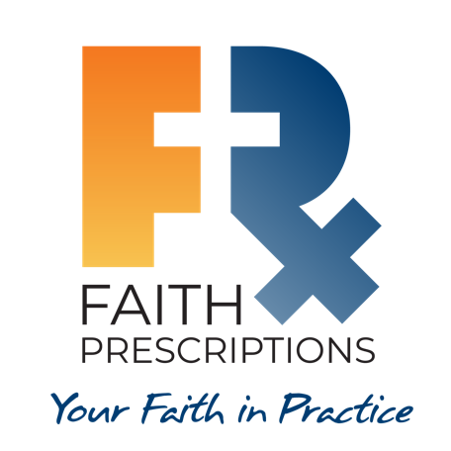
Leader’s Guide

Episode 25
End-of-Life Care, Part 2

Summary

The Bible does not give us every answer regarding how to best meet the needs of those who are terminally ill. It does, however, provide foundational principles regarding decision-making near the end of their lives. Multiple factors will influence the treatment decisions of patients and those who love them. A scripturally wise healthcare professional can be a tremendous asset to patients and their families at this critical time.

Speaker

Kathryn Butler, MD, is a trauma and critical care surgeon living outside of Boston, Massachusetts. She left clinical practice in 2016 to homeschool her children and writes regularly for the Gospel Coalition and desiringGod.org on topics intersecting faith and medicine. Her book, Between Life and Death: A Gospel-Centered Guide to End-of-Life Medical Care (Crossway, 2019), examines end-of-life dilemmas through a Christian lens. Dr. Butler can be reached through her website www.kathrynbutler.com.

Discussion Questions

- What from this video inspired, edified or challenged you?

- Dr. Butler lays out four key principles regarding end-of-life care. Do you believe these principles are biblically supported? Consider the following passages, and others that might come to mind.

a. Mortal life is sacred, and we are all image-bearers of God.
Genesis 1:27, Genesis 9:6, Psalms 139:13-16, Luke 12:6-7

b. God has ultimate authority over life and death, and our times are in His hands.
Job 14:5, Deuteronomy 32:39, Hebrews 9:27

c. Mercy and compassion—love our neighbor as ourselves.
Psalms 145:8-9, John 3:16, Romans 5:8, 2 Corinthians 1:3-4

d. Our hope in Christ, and God’s love for us is so vast that nothing can separate us from Him.
Psalm 118:14-15, John 11:25-26, Romans 8:35-39, Romans 14:8, 2 Corinthians 5:17-18

Each of these principles is well-supported by the Scriptures of the Old and New Testaments. Therefore, they represent timeless wisdom in our consideration of end-of-life care.

- How might you respond to someone who had a condition that could be treated predictably, but who refused treatment because of respect for God’s sovereignty over life and death?

God, in His sovereignty, has enabled us to discover medical treatment options that enable us to extend earthly life. Your disease can be treated predictably, and if you decline life-preserving treatment, you will not be able to accomplish all He has for you to do on this earth. You will eventually go to be with Him, but not yet! (See also Philippians 1:22-25.)

- Dr. Butler makes reference to “medical futility,” a potential factor in end-of-life care.

a. How could this factor be helpful in considering appropriate care?

If there is hope that life-supporting measures could allow for partial or complete
resolution of the disease, then such measures can be a positive step in the health of
the patient. However, if there is no reasonable likelihood that time or additional
treatment will improve the patient’s state of health, patients and loved ones should not feel obligated to accept treatments, especially if such measures will prolong death and worsen suffering.

b. How could a distorted view of “medical futility” be misconstrued as potential justification for euthanasia?

The physician’s declaration of a state of “medical futility” should be based primarily on the physician’s professional determination of the patient’s state of physical health, as well as the likelihood of further treatment improving the situation. The idea of “medical futility” can help guide healthcare professionals, families and patients wrestling with whether to accept aggressive interventions at the end of life, but it is never a justification for the active taking of life via euthanasia or assisted suicide. A patient should not have the right to demand the active termination of their life merely because they have lost the will to live or because medical treatments are deemed futile. There is a key distinction between declining interventions that will not help, and the active taking of life through chemical means. Medical futility can be temporary and transitory; it should be used as a guide to determine when medical treatments may cause further harm, but never wielded as justification for assisted suicide.

- Why is it important for healthcare professionals to be having spiritual dialogue with a patient throughout life, rather than just at the end of life?

If the doctor-patient relationship over the years includes a spiritual component, then the patient will not be surprised when faith is addressed at the end of life. Also, ideally the healthcare professional’s efforts to provide excellent care over the years should be seen by the patient as an outgrowth of the caregiver’s relationship with the Lord. This ongoing spiritual dialogue with the patient can also be accompanied by other individuals in the patient’s life, which can help to confirm the legitimacy of the gospel, thereby making it more likely the patient will embrace Christ and grow in his/her faith.
6. How would you address the following situations?
a. An 87-year old man with end-stage liver disease, hypertensive cardiomyopathy with an ejection fraction of 30 percent and multiple myeloma was admitted to the ICU with urosepsis. He ultimately required intubation as his septic shock progressed to acute renal failure and ARDS. Three weeks after presentation, he is in multiorgan failure, coagulopathic, with worsening oxygenation and a rising pressor requirement despite broad-spectrum antibiotics. During a goals of care meeting, the patient’s son states, “My dad believes in the God of the Bible. Under no circumstances are you to take him off life support.”

The “God of the Bible” says there is “a time to be born, and a time to die” (Ecclesiastes 3:2a, ESV). He also says, “And just as it is appointed for man to die once, and after that comes judgment (Hebrews 9:27, ESV). And He also says furthermore, “O death, where is your sting?” (1 Corinthians 15:54-56) for the one who belongs to the Lord.

b. A 69-year old woman with recurrent stage IV glioblastoma multiforme, on palliative steroids but without any further treatment options, presents in septic shock from perforated diverticulitis. She undergoes an emergency Hartmann procedure, which she tolerates from a hemodynamic standpoint, but she is unresponsive post-operatively and is noted to have a dilated and fixed pupil. A CT scan confirms a large bleed from her cerebral tumor, with significant midline shift. During an urgent meeting with her family, a daughter says her mother had enrolled in home hospice services and became tearful at the mention of CPR and ventilators. “But I want you to keep going,” she adds. “I’m praying for a miracle, and I need you to keep doing everything until God answers.”

As Dr. Butler says, God doesn’t need a ventilator to do a miracle. One possible response might be, “How long would you like to keep your mother on life support, until you consider the possibility that the Lord is calling her home?” A second response could be, “Your mother’s ultimate healing will not happen until after her earthly death. The Bible promises her an incorruptible body in eternity (1 Corinthians 15:35-58).
7. What is one take-home item from today’s session that you hope to implement?

Additional Resources

- Medical Ethics and the Faith Factor: A Handbook for Clergy and Healthcare Professionals by Robert Orr
- Hostility to Hospitality: Spirituality and Professional Socialization within Medicine by Michael and Tracey Balboni
- Between Life and Death: A Gospel-Centered Guide to End-of-Life Medical Care by Kathryn Butler

