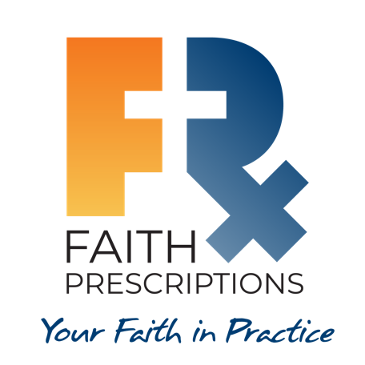
Leader’s Guide

Episode 11
Training Segment for Medical and Dental Students

Summary

The very best time for a healthcare professional to begin integrating spiritual interventions into patient care is during their initial training. Even during their training years, students can begin communicating their faith by praying with patients and taking a spiritual history, as well as various other ways. The development of a healthcare professional’s capacity to meet a patient’s physical needs should ideally be accompanied by training to address spiritual needs as well.

Speaker
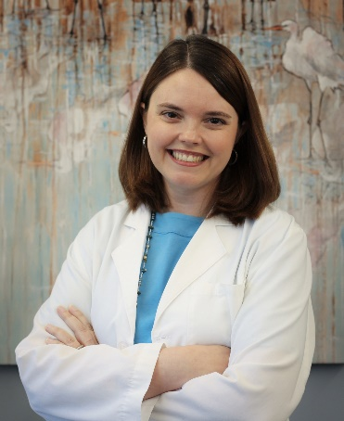
Dr. Cathie Scarbrough is a faculty physician with the Gadsden Regional Medical Center Family Medicine Residency Program in Gadsden, Alabama. Her interests include women's health, whole-person medicine and global health. She has been a member of CMDA since medical school, and she enjoys teaching family medicine overseas. In her spare time, she likes gardening, baking and hanging out with her French bulldog, Stella. For further information or to contact Dr. Cathie Scarbrough, please email her at cpscarbrough@gmail.com.

Discussion Questions

- What from this video inspired, edified or challenged you?

- As a student or resident, have you had the opportunity to interact with a patient on a spiritual level (take a spiritual history, discuss a faith flag, offer or share prayer, etc.)? How did it go? Would you do anything differently next time?

It can be a bit intimidating as a student taking spiritual histories and praying with patients. However, as one begins to make the spiritual history a regular part of the Social History as part of a History & Physical, it becomes a routine event. Eventually it can become even easier to ask the spiritual history questions than the sexual history questions that one sometimes has to ask. Although most patients are open to answering the questions, some are not—and with those, one can simply move on to the next questions in the social history.

However, for those patients who DO engage, whether in the positive or negative, it has led to many deep conversations on life and purpose and our source of hope and strength in times of illness, etc. These are questions we all will grapple with one day as humans, and we have a unique privilege to speak into these issues with our patients. As we do so, it is important we point them to the source of our hope and strength, Jesus Christ.

- What are some of your own reservations about sharing with patients? Are you personally comfortable with sharing? Why or why not?

The more one engages in spiritual interventions with patients, the more natural it will become. However, at certain points everyone will get into a time crunch with clinic schedules and the busyness of the day, which can affect the time available to address spiritual patient concerns. It is easy to get caught up in watching the clock and trying to stay on schedule. Building in longer appointment times can help, as this can create some “cushion” for when one patient may need more attention.

One thing that makes it harder to share with patients is if spiritual issues have not been addressed from the beginning. If there is no spiritual interaction with a patient for a couple of years and then an occasion for a spiritual intervention arises, it will be more awkward to address it “out of the blue” than if there had been prior spiritual exchanges along the way. For this reason, it is good to begin right at the beginning with a spiritual history, to set the tone for future spiritual opportunities all along a patient’s journey and not just when something bad arises.

- Liz Flaherty began a student Bible study at the University of Minnesota. What are some ways God could work through a Bible study at your school? How might you go about starting one or making it better?

Starting a study is just a matter of finding an available space and announcing the study to your classmates, perhaps with a partner for wisdom and support. God could work as He did in Liz’s group—by helping you to discover the Christians in your class, and also by introducing students unfamiliar with the Bible to its amazing contents. If you have a study, inviting others is a great way to make the study better, along with praying for the Lord’s work in the lives of all who attend. Perhaps the group could also benefit from inviting a Christian faculty member or local healthcare professional to speak to the group.

- 1 Peter 3:15 – Dr. Scarbrough discussed providing hope to our patients. According to Peter, how can we do that?
Our ability to clearly communicate the gospel and our testimony of what Jesus has done in our lives can provide a living hope that we can share with those who are not yet believers. Being able to articulate clearly and succinctly who Jesus is and the message of the gospel are critical to giving hope to our patients and colleagues.

- Dr. Edmund Thomas speaks of being invited to a Bible study during dental school, then going on a mission trip where he “heard that same gospel message preached by a completely different set of people.” Has God used multiple sources to confirm the truth of the gospel in your life? Perhaps there is a seeker in your life, waiting for a confirmation from someone like you!

It is very rare for a person to come to Christ in their first exposure to the gospel. Rather, people tend to make multiple steps toward embracing Christ. We should seek to inspire others to move them closer to Christ, allowing the Holy Spirit to guide and direct their journey.

- James 5:16 – James emphasizes prayer having a place in our healing. How do you think prayer can benefit our patients?

Prayer demonstrates a care and concern for others in one of the deepest ways possible. God can work through prayer to bring about healing, either by using us or perhaps by healing supernaturally without our help. It shows that we take seriously the pain of others, and it helps focus our patients’ hearts on God. In addition, praying with our patients is a sign to the patient that we recognize our own human limitations and the call to acknowledge God as the ultimate healer. As we point to the Lord, this may redirect a patient’s attention from their own efforts to the incomparable work of Jesus Christ.

- As a student, you just returned to the call room and report that your patient was agreeable and happy to accept prayer prior to their surgery planned later today. Your upper-level resident looks at you and says, “Why did you do that? We have chaplains who come around for that kind of stuff.” How would you respond?

One answer might be, “Well, yes, the chaplain is available, and s/he has been consulted. But I wanted to make sure that the patient’s needs were met prior to them going to surgery.”

- Dr. Farr Curlin calls students to “be light and salt” (Matthew 5:13-14). In the world of healthcare, what are some ways you can do this, even as a student?

Excellent, compassionate care for patients with an attitude of humility, combined with verbal acknowledgements of the importance of the Lord in your life, are a powerful combination in proclaiming the Good News of what Jesus has done, and continues to do, for us.

- Matthew 9:35-38 – What does Jesus ask His disciples to pray for? How can you answer that call from Jesus?

Jesus asks His disciples to pray for workers for His harvest. He is looking for people who care about the eternal souls of people around them and can communicate that care and concern through their words and through their lives. Our allegiance to Christ should produce a concurrent focus on being about His work of drawing all people to Him (John 12:32).

- What is one take-home item from today’s session that you hope to implement?

Things to Consider:

- In a survey of 1,591 patients at the Mayo Clinic, 70 percent of hospitalized patients wanted to see a chaplain, but only 43 percent were visited by a chaplain.
- The Mayo Clinic rate of inpatients actually seen by chaplains is over double the national rate, which is only 20 percent.
- Spiritual needs are widespread among medical patients. When these needs are not addressed by the medical team, the patient’s quality of life and satisfaction with care is reduced and healthcare costs double or triple, at least toward the end of life.
- Furthermore, randomized clinical trials show that when physicians conduct a spiritual assessment, the result is a better doctor-patient relationship, better compliance with visits, lower depression and greater functional well-being.

References:

- https://spiritualityandhealth.duke.edu/images/pdfs/CME5%20Guide.pdf
Balboni et al. (2011). Support of cancer patients' spiritual needs and associations with medical care costs at the end of life. Cancer 117(23):5383-5391
- Kristeller et al. (2005). Oncologist Assisted Spiritual Intervention Study (OASIS): Patient acceptability and initial evidence of effects. International Journal of Psychiatry in Medicine 35:329–347
- Huguelet et al. (2011). A randomized trial of spiritual assessment of outpatients with schizophrenia: patients' and clinicians' experience. Psychiatric Services 62(1):79-86

Additional Resources

- Healthcare Education and the Christian Faith. (1999, May 1). Retrieved from CMDA Position Statements: https://cmda.org/wp-content/uploads/2018/04/Healthcare-Education-with-References.pdf
- Sharing Faith in Practice. (1997, May 9). Retrieved from CMDA Position Statements: https://cmda.org/wp-content/uploads/2018/04/Sharing-Faith-in-Practice-with-References.pdf
- Koenig, H. (2012). Religion, Spirituality, and Health: The Research and Clinical Implications. ISRN Psychiatry, Article ID 278730.
- Koenig, H. G. (2007). Spirituality in Patient Care. Why, How, When, and What. Second Edition. West Conshohocken: Templeton Press.
- Larimore W. Spiritual Assessment in Clinical Care. Part 1—The Basics. Today’s Christian Doctor 2015(Spring):46(1):22-26.
- Larimore W. Spiritual Assessment in Clinical Care. Part 2—The LORD’s LAP. Today’s Christian Doctor. 2015(Fall):46(3):26-29.
- Rudd, G. (2017). Potential Reactions. Grace Prescriptions, pp. 99-100.

