Leader’s Guide

Episode 18
Practicum Makes Perfect

Summary

This episode is primarily for resident groups who study Faith Prescriptions and would like to become more comfortable with what they have learned. Residents practice spiritual interventions while exercising the important principles of treating patients with sensitivity and respect, while also asking permission along the way. Those interested in providing this highly useful opportunity for residents will appreciate the description of how it works, as well as illustrations of potential benefits. Also included are some great testimonies of former residents who studied under Dr. Greuel and others at the In His Image residency program in Tulsa, Oklahoma. See below for a step-by-step guide to Practicum patient visits.

Speaker
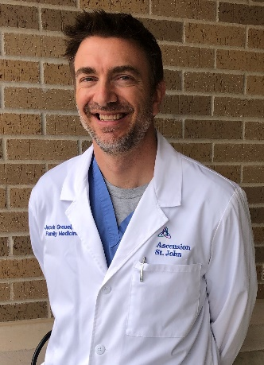
Dr. Jacob Greuel was raised in church, but as a young adult faltered until he had an encounter with God during medical school that dramatically altered the course of his life. While in family medicine residency, a faculty member led he and others through CMDA’s Saline Solution. Subsequently, sharing the love of Christ became paramount in his Alabama private practice. Then he and his wife realized a call beyond that practice and short-term missions to “multiply medical ministry”. To that end, he completed a fellowship in obstetrics and currently serves on the faculty at In His Image Family Medicine Residency Program in Tulsa, Oklahoma. Dr. Greuel is passionate about training others to magnify the Lord, especially through the practice of medicine. He also enjoys being active in the outdoors and spending time with his wife and their four sons. Dr. Greuel can be contacted at greueljv@yahoo.com.

Recommended Practicum Protocols

- The lead person greets the patient and family, if present.
- Introduce the team, explaining “We’re not a part of your primary medical team, but are medical professionals trying to improve whole-person care. Could we visit with you for a few minutes regarding your spirituality or religion?
- Respect the patient and be willing to back off politely and move on without pushing it if the patient directly refuses at any point.
- Be aware of the patient’s implied verbal and nonverbal communication and ensure the patient is comfortable continuing with the conversation. If you’re not sure, just ask, “Would it be okay if we continue…?
- If the patient agrees to participate, the presenter could use the LORD’s LAP acrostic learned and practiced during the seminar (assuming we are still using this acrostic).
- During the time of conversation, the presenter may use faith flags, faith stories, offer prayer, a chaplain or pastoral referral, etc... as appropriate. Consider asking if the patient would you to pray with them, unless they have indicated that this offer would be unwelcome.
- At the end of the session, thank the patient for their participation, and consider eliciting brief feedback (i.e., “How did you think that went with regards to your care here?”) if the patient seems open to that and time allows.
- Debrief/ questions:
- What went well?
- What didn’t go well?
  - How would you do things differently in the future?
- How can you, right now, enact a plan to hold yourself accountable to applying the
principles learned in Faith Prescriptions? (Participants will take some action in this
area before leaving, i.e., set a reminder in their phone, plan to meet with another
participant later, etc...)

Additional Resources

- Your Best Life in Jesus Easy Yoke by Bill Gaultiere, Ph.D
- The Saving Life of Christ by Major W. Ian Thomas
- Don’t Waste Your Life by John Piper

