Effects of Nordic Hamstring Exercise on Hamstring Injuries in High
School Soccer Players: A Randomized Controlled Trial
Mohamed Almubiadin, PT, DPT, CSCS

Reference: Hasebe Y, Akasaka K, Otsudo T, Tachibana Y, Hall T, Yamamoto M. Effects of nordic hamstring exercise on hamstring injuries in high school soccer players: A randomized controlled trial. International Journal of Sports Medicine. 2020;41(03):154-160. doi:10.1055/a-1034-7854

Background:
- Hamstring muscle injuries are common in sports such as soccer and rugby, particularly during rapid acceleration and sprinting.
- The Nordic Hamstring Exercise (NHE) has been shown to reduce hamstring injury rates in professional and amateur soccer players.
- Factors affecting hamstring injuries among young soccer players and the effects of introducing a hamstring injury prevention program have not been extensively studied.
- The purpose of the study was to investigate the correlation between physical examination variables and hamstring injuries in high school soccer players and assess the impact of NHE and its compliance rate on the hamstring injury rate.
- Reduced hamstring flexibility and low hamstring/quad strength ratio (HQ ratio) are considered high risk factors for hamstring injuries.

Methods:
- Isometric knee extension and flexion muscle strength were measured using a manual muscle testing meter.
- The study included 259 male high school soccer players from seven schools in the Saitama Prefecture Football League.
- Cluster-randomization was used, with players assigned to either the NHE group (intervention group) or the control group.
- Measurement variables included functional evaluation (finger-floor distance, isometric knee extension and flexion strength, and 50 m running time) and survey recording (training and match hours per day, injury details, rest hours due to injury, NHE program participation).
- Knee extension was assessed at 90° knee flexion in the sitting position, while knee flexion was examined at 30° flexion in the prone position.
- Strength testing was performed twice, and the maximum value was used for analysis.
- The study measured the 50-meter run time of the participants using a stopwatch.
- Functional evaluation was conducted at each school by the research team, with the evaluator blinded to group allocation.
- Attendance, training duration, matches, and participation in the NHE program were recorded.
- Hamstring injuries were recorded in terms of presence or absence, time off from training or matches, and injury details.
- The NHE intervention was performed after normal training and before cool-down, focusing on eccentric loading of the hamstring muscles.

Findings: ·
Control Group Findings:
- Right HQ ratio of 0.73 ± 0.21 and a left HQ ratio of 0.73 ± 0.25.
- Mean 50-meter running time was 6.92 ± 0.35 seconds.
- No significant difference in the HQ ratio and finger-floor distance between players with and without hamstring injuries.
- Players with hamstring injuries had a significantly longer 50-meter running time (p = 0.03).
- Hamstring injuries occurred in 3 players.
- Hamstring injury rate of 1.04, a time-lost-to-sport injury rate of 1116.3, and a relative risk of 1.14 for hamstring injuries compared to the intervention group.
Intervention Group Findings:
- Right HQ ratio of 0.64 ± 0.17 and a left HQ ratio of 0.60 ± 0.15.
- Mean 50-meter running time was 6.73 ± 0.28 seconds.
- Significantly lower HQ ratio and faster 50-meter running time compared to the control group (p < 0.01).
- No significant difference in the HQ ratio, finger-floor distance, and hamstring injuries between players with and without hamstring injuries.
- Hamstring injuries occurred in 4 players.
- Hamstring injury rate of 0.88, a time-lost-to-sport injury rate of 113.7, and a relative risk of 1.52 for hamstring injuries compared to the control group.
Overall Findings:
- The NHE group showed a significantly reduced 50-meter running time compared to the control group.
- The intervention group had a lower hamstring injury rate and a lower time-lost-to-sport injury rate compared to the control group.
- The NHE intervention had a positive effect on reducing the severity of hamstring injuries in high school soccer players.

Limitations:
- The sample size of the study was relatively small, which may limit the generalizability of the findings to a larger population.
- The study only focused on high school soccer players, so the results may not be applicable to athletes in other sports or different age groups.
- The study did not assess other potential risk factors for hamstring injuries, such as previous injury history, training load, and individual biomechanics.
- The follow-up period was limited to one season, and long-term effects of the intervention were not investigated.

Clinical Implications:
- Implementing an (NHE) program may help reduce the risk of hamstring injuries in high school soccer players.
- Compliance with the NHE program is crucial for its effectiveness, so it is important to educate athletes, coaches, and staff on the correct application and supervision of the exercises.
- The NHE program may lead to improvements in physical function measures such as knee flexor strength and sprint performance.
- Physical therapists should consider including NHE exercises as part of the injury prevention and rehabilitation programs for high school soccer players.
- While the NHE program showed promising results in reducing the severity of hamstring injuries, it is important to address other potential risk factors and implement a comprehensive approach to injury prevention.
- Future research should explore the effects of NHE in different populations, sports, and age groups, as well as investigate long-term outcomes and the potential synergistic effects of combining NHE with other interventions.
- Physical therapists should emphasize the importance of proper warm-up and cool-down routines, adequate training load management, and addressing any muscle imbalances or flexibility deficits that may contribute to hamstring injury risk.
- Collaboration with coaches, athletic trainers, and medical staff is crucial to ensure a comprehensive approach to injury prevention, early detection, and appropriate management of hamstring injuries in high school soccer players.

Discussion Questions:
- What factors contribute to the compliance or non-compliance of athletes with the NHE program, and how can compliance be improved?
- What are the potential mechanisms by which the NHE program improves physical function measures such as knee flexor strength and sprint performance?
- In what ways can physical therapists effectively educate athletes, coaches, and staff about the importance and proper implementation of the NHE program?
- What other strategies or interventions could be combined with the NHE program to further enhance injury prevention outcomes in high school soccer players?
- How do the findings of this study contribute to the existing evidence on the effectiveness of the NHE program in reducing hamstring injuries?
- What are the potential reasons for the lack of significant association between hamstring injury risk and physical function measures such as hamstring-to-quadriceps (HQ) ratio and finger-floor distance?
- What are the practical challenges and considerations in implementing the NHE program within the high school soccer setting, and how can these be addressed to ensure optimal compliance and effectiveness?
- How can the findings of this study be translated into clinical practice by physical therapists working with high school soccer players to enhance injury prevention strategies and optimize athletes' performance?

Eccentric strengthening effect of hip-adductor training with elastic bands in soccer players: a randomised controlled trial

Reference: Jensen J, Hölmich P, Bandholm T, et alEccentric strengthening effect of hip-adductor training with elastic bands in soccer players: a randomised controlled trialBritish Journal of Sports Medicine 2014;48:332-338.

Background:
- Adductor-related groin injuries are the second most common muscle injury and most common in the hip/groin region in soccer
- Decreased adductor strength is a risk factor for groin injuries; hip adductor strength training would be relevant for groin injury prevention
- Soccer players demonstrate greater hip abductor eccentric strength compared to adductor eccentric strength
- Hip adductor muscle-tendinous complex is stressed in soccer, especially during kicking
- Increased hip adduction strength may:
  - Protect structures during large eccentric forces
  - Increase energy absorption in the tissues
  - Decrease stress at tendon and insertion sites
  - Prevent overuse injuries and acute tears
- Strength training using elastic band:
  - Simplicity, can perform in different settings
  - Effective in strength training
  - Strength training benefits have not been assessed for hip-adductor gains
- Purpose:
  - To investigate the effect of an 8-week hip-adduction strength training program using elastic bands on hip muscle strength in healthy soccer players

Methods:
- 34 healthy male sub-elite soccer players (22.1 ±3.3 yrs) during mid-season break
  - Soccer training 2-4x/week, 1-2 weekly matches
  - Exclusion: had an injury of low back, lower extremity, and/or hip/groin of more than 6 weeks in the past year; groin pain during soccer play of more than 1 week in the last 3 months; hip.groin pain in the last month; performed systematic hip adductor strength training for more than 1x/wk in the preceding 6 months
  - Randomly assigned to training group or control group; blinded
- Training intervention:
  - Performed as group training supervised by a PT
  - Exercise: dynamic and isometric hip-adduction in standing with elastic bands attached to fixation point
  - Duration of intervention, external load, repetitions, sets, and training sessions:
    - Week 1-2: 3 sets of 15±2 RM; 2x/week
    - Week 3-6: 3 sets of 10±2 RM; 3x/week
    - Week 7-8: 3 sets of 8±2 RM; 3x/week
  - Exercise performed:
    - In full ROM from abduction to adduction
    - 3-sec concentric, 2-sec isometric, 3-sec eccentric hip-adduction; 2-sec pause in max hip-abduction
    - 1 minute rests between each set; 24 hours at least between each session
    - Increased external load by: heavier elastic band, increase distance from fixation, add extra band
- Control group: did not perform adductor strength training; continued to play soccer
- Outcome measures:
  - Primary: max eccentric (EHAD) and max isometric (IHAD) hip-adduction strength
  - Secondary: max isometric hip-abduction (IHAB) strength, IHAD:IHAB ratio
  - Hand-held dynamometer; performed on preferred kicking leg
  - Week 1 (pretest) and 3-6 days post intervention (post-test)
  - Other measurements: training compliance, DOMS and perceived loading of training sessions, number of soccer training sessions and games
Findings:
- Within group:
  - Training group:
    - Increased EHAD strength by 30%, increased IHAD strength by 14%, increased IHAB strength by 17% after 8 weeks
    - IHAD/IHAB ratio: 1.27 at baseline to 1.24 after 8 weeks
  - Control group:
    - Increased EHAD strength by 17%
    - IHAD strength was 1.68 Nm/kg at baseline and 1.80 Nm/kg after 8 weeks
    - Increased IHAB by 21%
    - IHAD/IHAB ratio decrease by 10%
  - Between group:
    - 13% significantly greater EHAD strength in training group
    - No significant between group differences for IHAD, IHAB, or IHAD/IHAB ratio
Limitations:
- Sample size
- Only measure hip-adduction strength on dominant leg even though hip-adduction interventions were aimed at both legs
Clinical Implications:
- Using an elastic band is a simple hip adduction strengthening modality that can be performed easily in different settings.
- Hip-adduction strengthening programs should be used as a preventative approach towards adductor-related groin injuries in soccer players, especially in players with decreased hip-adduction strength.
- Further investigation is required to assess influence on risk of hip-adductor related groin injuries in soccer players in a randomized clinical study.

Discussion Questions:
- Do you assess hip adduction strength in pre-season screenings?
- What type of injury prevention do you incorporate for groin injuries?

The FIFA 11+ Shoulder Injury Prevention Program Was Effective in Reducing Upper Extremity Injuries Among Soccer Goalkeepers A Randomized Control Trial

Reference: Al Attar, W. S. A., Faude, O., Bizzini, M., Alarifi, S., Alzahrani, H., Almalki, R. S., ... & Sanders, R. H. (2021). The FIFA 11+ shoulder injury prevention program was effective in reducing upper extremity injuries among soccer goalkeepers: a randomized controlled trial. The American journal of sports medicine, 49(9), 2293-2300.

Background:
- Soccer has over 200 million participants, in recent years UE injury (specifically shoulder) have increased especially in goalkeepers
  - Ball Stops, frequent reaching, landing on the field, shifting upper limb positions
- Shoulder Injuries
  - 2004 European Football Championship 3.8% and Olympic Games Athens 4.4%
  - FIFA 2002 to 2006 4.6%-8.2%
  - NCAA 4.6x injury rate of goalkeepers compared to outfield players
- FIFA 11+ Injury prevention program helps decr injury rates in soccer players (approx 34% in recreational players) → Development of FIFA 11+S (FIFA 11+ Shoulder) developed as a result
  - Neuromuscular control, core stability, ECC rotator strength, agility
Methods:
- Double Blind RCT → Neither participant nor researcher knows treatment allocation until trial is complete
- Participants/Recruitment
  - Local/Regional Amateur Goalkeepers in Saudi Arabia (n = 726, 360 I 366 C)
    - Through Saudi Federation of Sports Medicine + Saudi Arabian Football Federation
  - IC/EC
    - I:
      - Male Goalkeepers
      - 18-35 yo
      - >/= 1 match per week and/or >/=2 training sessions per week
      - Health Declaration Form prior to randomization
    - E:
      - UE injury requiring medical attention within 6 months
      - CV disease
      - Neurological disorders
      - Bony Fx
      - Surgery in previous year
- Randomization/Blinding
  - GK randomization completed via randomizer.org
    - Not aware of intervention in either control or intervention group
  - Procedure Described to Medical Staff (Team MD and Team PT)
    - Responsible for tracking goalkeepers/recording exposure times/number of injuries sustained during study
- Intervention
  - Control Group → Usual warm-up for all training sessions for 1 season (6 months)
  - Experimental Group → FIFA 11+S, 20-25 min completion for 1 season (6 months) see below
- Outcomes
  - Incidence of Overall UE Injury: # of injuries per 1000 exposure hrs for matches+training
  - MOI: Contact vs Non-contact vs overuse
    - C: Direct injury by external blow/force
    - NC: indirect injury from internal forces (over stretching, poor technique, fatigue, lack of fitness)
    - O: injury over time secondary to excessive repetitive loading
  - Type of Injury: initial vs recurrent
  - Severity of Injury
    - Minor: 1-7 days lost
    - Moderate: 8-21 days lost
    - Severe: >21 days lost
  - NO TRUE PRIMARY OUTCOME
  - Secondary
    - Compliance w/ interventions for both groups
- Stats:
  - Injury Risk Ratio (new standard for analyzing efficacy of injury programs)
    - (# of injuries in EG / Hrs of total exposure) / (# of injuries in CG / Hrs of total exposure)
Findings:
- Overall Injury Rate per 1000 Exposure-Hours
  - During a single season, 50 injuries (0.62 injuries per 1000 exposure-hours) were reported in the experimental group,
  - 122 injuries were reported in the control group (1.94 injuries/1000 hours).
  - The FIFA 11+S program reduced the total number of upper extremity injuries by nearly 70%
- Odds of sustaining recurrent injury → 4.05x higher in control
  - 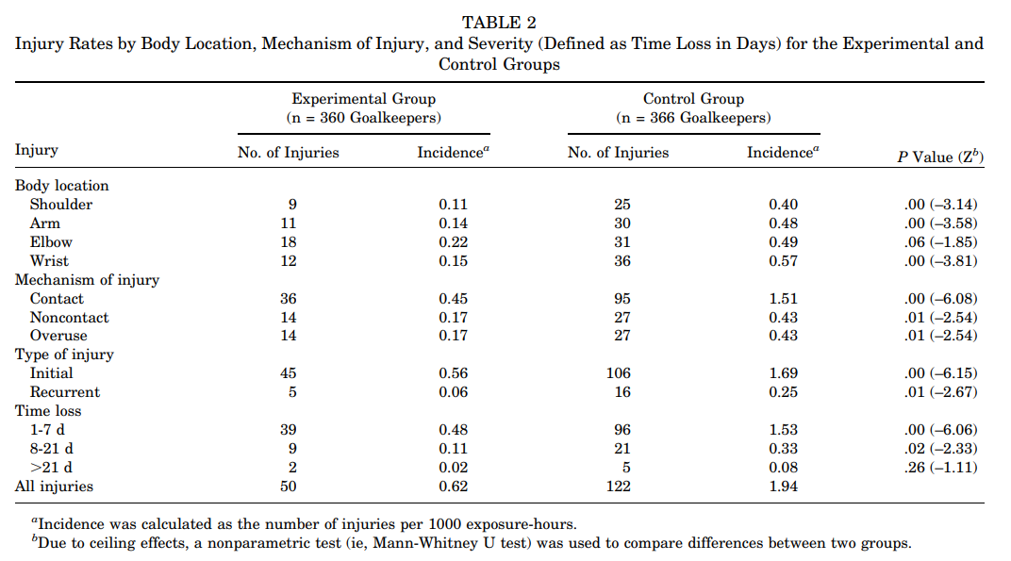

Limitations:
- Only amateur male soccer goalkeepers were recruited for the study; thus, findings cannot be generalized to professional goalkeepers or female soccer goalkeepers.
- The control group were instructed to continue their usual warm-up programs, and these programs were not standardized across participants; therefore, within group variation is to be expected.
- The long-term effects of the FIFA 11+S program beyond 1 season were not investigated.
- No standardized primary outcome regarding upper extremity injury/function was used
- No formal training/S&C for each group was established (did they complete anything outside of the formal practice/FIFA11+S)

Clinical Implications:
- Goalkeeper specific warm-up that can be integrated into training and games to reduce UE injury with minimal time commitment
- Standardized with specific domains

Discussion Questions:
- Are there certain portions of the FIFA11+S that can be omitted but still be effective?
- How does the FIFA11+S compare to other UE injury prevention programs like: Thrower’s 10, Oslo Sports Trauma Research Center shoulder injury prevention, etc?
- Would the effectiveness of the program change depending on the skill level of the player or depending on the overall match/practice time for the goalkeeper?
- How would this compare to GK’s who already have a formal training program involving UE movements/training concepts?
- What are the implications for a GK returning from an UE injury? Can it prevent recurrent injury within this subgroup?
