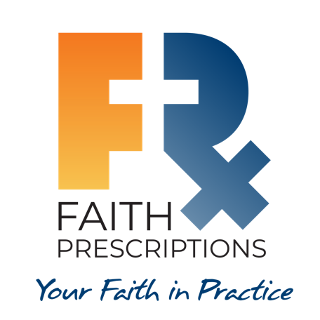
Participant’s Guide

Episode 11
Training Segment for Medical and Dental Students

Summary

The very best time for a healthcare professional to begin integrating spiritual interventions into patient care is during their initial training. Even during their training years, students can begin communicating their faith by praying with patients and taking a spiritual history, as well as various other ways. The development of a healthcare professional’s capacity to meet a patient’s physical needs should ideally be accompanied by training to address spiritual needs as well.

Speaker
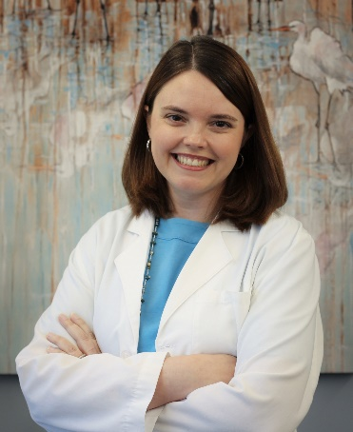
Dr. Cathie Scarbrough is a faculty physician with the Gadsden Regional Medical Center Family Medicine Residency Program in Gadsden, Alabama. Her interests include women's health, whole-person medicine and global health. She has been a member of CMDA since medical school, and she enjoys teaching family medicine overseas. In her spare time, she likes gardening, baking and hanging out with her French bulldog, Stella. For further information or to contact Dr. Cathie Scarbrough, please email her at cpscarbrough@gmail.com.

Discussion Questions

- What from this video inspired, edified or challenged you?

- As a student or resident, have you had the opportunity to interact with a patient on a spiritual level (take a spiritual history, discuss a faith flag, offer or share prayer, etc.)? How did it go? Would you do anything differently next time?

- What are some of your own reservations about sharing with patients? Are you personally comfortable with sharing? Why or why not?

- Liz Flaherty began a student Bible study at the University of Minnesota. What are some ways God could work through a Bible study at your school? How might you go about starting one or making it better?

- 1 Peter 3:15 – Dr. Scarbrough discussed providing hope to our patients. According to Peter, how can we do that?

- Dr. Edmund Thomas speaks of being invited to a Bible study during dental school, then going on a mission trip where he “heard that same gospel message preached by a completely different set of people.” Has God used multiple sources to confirm the truth of the gospel in your life? Perhaps there is a seeker in your life, waiting for a confirmation from someone like you!

- James 5:16 – James emphasizes prayer having a place in our healing. How do you think prayer can benefit our patients?

- As a student, you just returned to the call room and report that your patient was agreeable and happy to accept prayer prior to their surgery planned later today. Your upper-level resident looks at you and says, “Why did you do that? We have chaplains who come around for that kind of stuff.” How would you respond?

- Dr. Farr Curlin calls students to “be light and salt” (Matthew 5:13-14). In the world of healthcare, what are some ways you can do this, even as a student?

- Matthew 9:35-38 – What does Jesus ask His disciples to pray for? How can you answer that call from Jesus?

- What is one take-home item from today’s session that you hope to implement?

Things to Consider:

- In a survey of 1,591 patients at the Mayo Clinic, 70 percent of hospitalized patients wanted to see a chaplain, but only 43 percent were visited by a chaplain.
- The Mayo Clinic rate of inpatients actually seen by chaplains is over double the national rate, which is only 20 percent.
- Spiritual needs are widespread among medical patients. When these needs are not addressed by the medical team, the patient’s quality of life and satisfaction with care is reduced and healthcare costs double or triple, at least toward the end of life.
- Furthermore, randomized clinical trials show that when physicians conduct a spiritual assessment, the result is a better doctor-patient relationship, better compliance with visits, lower depression and greater functional well-being.

References:

- https://spiritualityandhealth.duke.edu/images/pdfs/CME5%20Guide.pdf
Balboni et al. (2011). Support of cancer patients' spiritual needs and associations with medical care costs at the end of life. Cancer 117(23):5383-5391
- Kristeller et al. (2005). Oncologist Assisted Spiritual Intervention Study (OASIS): Patient acceptability and initial evidence of effects. International Journal of Psychiatry in Medicine 35:329–347
- Huguelet et al. (2011). A randomized trial of spiritual assessment of outpatients with schizophrenia: patients' and clinicians' experience. Psychiatric Services 62(1):79-86

Additional Resources

- Healthcare Education and the Christian Faith. (1999, May 1). Retrieved from CMDA Position Statements: https://cmda.org/wp-content/uploads/2018/04/Healthcare-Education-with-References.pdf
- Sharing Faith in Practice. (1997, May 9). Retrieved from CMDA Position Statements: https://cmda.org/wp-content/uploads/2018/04/Sharing-Faith-in-Practice-with-References.pdf
- Koenig, H. (2012). Religion, Spirituality, and Health: The Research and Clinical Implications. ISRN Psychiatry, Article ID 278730.
- Koenig, H. G. (2007). Spirituality in Patient Care. Why, How, When, and What. Second Edition. West Conshohocken: Templeton Press.
- Larimore W. Spiritual Assessment in Clinical Care. Part 1—The Basics. Today’s Christian Doctor 2015(Spring):46(1):22-26.
- Larimore W. Spiritual Assessment in Clinical Care. Part 2—The LORD’s LAP. Today’s Christian Doctor. 2015(Fall):46(3):26-29.
- Rudd, G. (2017). Potential Reactions. Grace Prescriptions, pp. 99-100.

