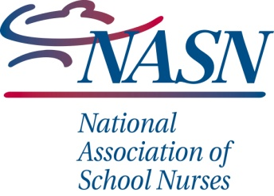
School Nurse Yearly Goals
The Standards of School Nursing includes the use of the nursing process (assessment through evaluation) by school nurses, including their personal and professional development.
Student-Focused Goal
Trends /data of concern from last year

SMART Goal (Specific, Measurable, Attainable, Results-oriented, and Time-bound)

Activities to support goal achievement | Timeline/dates

Nurse’s Professional Development
Framework Identification Area (Standards of Care, Care Coordination, Leadership, Quality Improvement, Community/Public Health)

SMART Goal (Specific, Measurable, Attainable, Results-oriented, and Time-bound)

Activities to support goal achievement | Timeline/dates

