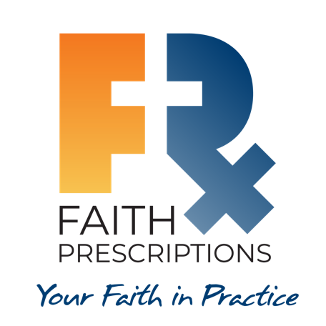
Participant’s Guide

Episode 8
Sharing The Good News

Summary

Jesus calls us to confess him before men in Matthew 10:32, and at times this can be an intimidating responsibility. What is the basis for our apprehensions, and how can the power of the Gospel transform both us and our patients? This session demonstrates how our fears can give way to a greater recognition of God’s grace in our lives, turning this responsibility into a privilege.

Speaker
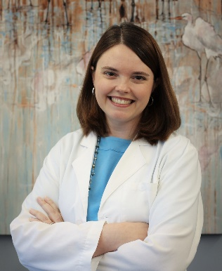
Dr. Cathie Scarbrough is a faculty physician with the Gadsden Regional Medical Center Family Medicine Residency Program in Gadsden, AL. Her interests include women's health, whole-person medicine, and global health. She has been a member of CMDA since medical school and enjoys teaching Family Medicine overseas. In her spare time, she likes gardening, baking, and hanging out with her French bulldog, Stella. For further information or to contact Dr. Cathie Scarbrough, please email her at cpscarbrough@gmail.com.

Discussion Questions

- What from this video inspired, edified or challenged you?

- What are some of your own reservations about sharing the gospel with patients? Are you personally comfortable with sharing? Why or why not?

- Read Luke 9:2. What was the dual mission Jesus sent His disciples to do? How does this concept apply to our practices today?

- Dr. Scarbrough stated, “Fear is not dispelled, it doesn’t go away, by having a storehouse of answers…fear is dispelled by having a right attitude toward the Lord.” Why does our knowledge of apologetics (a defense of the faith) not dispel fear? If this is true, then why study apologetics?

- What are some of the components of “a right attitude toward the Lord” that can help to dispel our fear?

- Why is it important to bring Scripture into our presentations?

- Dentist/physician Dr. Linda Huong shares how a dental office manager came to Christ through her willingness to share personal protective equipment (PPE) with their office during the COVID-19 pandemic. Were any of you pointed to Jesus by the unexpected kindness and generosity of those motivated by His love?

- As a student, you just returned to the call room and report that your patient was agreeable and happy to accept prayer prior to their surgery planned later today. Your upper-level resident looks at you and says, “Why did you do that? We have chaplains that come around for that kind of stuff.” How would you respond?

- What is one take-home item from today’s session that you hope to implement?

Additional Resources

- Lennox, J. C. (2018). Have No Fear. Leyland: 10Publishing.
- Stevens, MD, David (Host). (2014, October). Witnessing in Practice, an interview with Randall P. Owen, MD, MS, FACS [Audio podcast]. Retrieved from https://cmda.org/christian-doctors-digest-october-2014/.
- Rudd, G. (2017). Potential Reactions. Grace Prescriptions, pp. 99-100.
- Williams, P. (2016). Intentional: Evangelism That Takes People to Jesus. Leyland: 10Publishing.
- Tice, R. (2015). Honest Evangelism: How to Talk About Jesus Even When it is Tough. Croydon: The Good Book Company.
- Prime, D. (2011). This Way to Life: Discovering Life to the Full. Leyland: 10Publishing.
- Hummel, C. (1994). Tyranny of the Urgent. Downers Grove: InterVarsity Press.

