Participant’s Guide

Episode 2
The Case for Practicing Medicine Christianly – Part 1

Summary

Our identity in Christ is the foundation for our efforts to provide excellent care for our patients. Any attempt to artificially separate our faith from our professional lives will be detrimental to both our well-being and that of our patients. Our faith may make us a bit “different” from our colleagues, but this is a difference that God can use for His glory.

Speaker

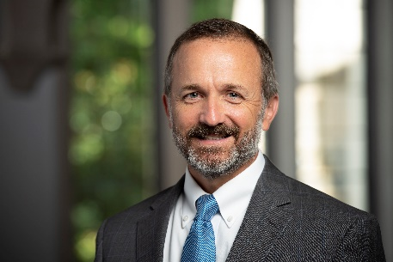
Farr Curlin, MD, is the Trent Professor of Medical Humanities and Co-Director of the Theology, Medicine, and Culture Initiative (TMC) at Duke University. Dr. Curlin’s ethics scholarship takes up moral questions that are raised by religion-associated differences in physicians’ practices. He is an active palliative medicine physician and holds appointments in both the School of Medicine and the Divinity School, where he and colleagues offer Christian theological formation to those with vocations to health care.

Discussion Questions

- What from this video inspired, edified or challenged you?

- Dr. Curlin explains the change in terminology that has occurred in our society’s reference to physicians as providers. How have you felt this distinction in your own practice? How do you react now that you’ve had the chance to think about it?

- If a Christian healthcare professional strives to separate their faith from their practice, how could this affect their:

- quality of care?
- tendency toward burnout?
- calling into healthcare?

- Consider Romans 12:2. How might we apply this verse to the perceived “secular-sacred” dichotomy?

- Dr. Curlin states, “Medicine is a human practice, and as a human practice is subject to distortion and corruption.” What could be preventing us from realizing this?

- How have you seen imperfections of humanity show up in your practice in a push to embrace progress?

- Dr. Curlin states, “I’ve talked to many Christians around the country in the past two decades in healthcare and heard them say things like, “You know, they would never allow one to do this,” or “You can’t do that,” or “You can’t say this,” or “This is not allowed.” And when I ask them, “Really? How do you know that?” It’s few of them who have actually tried to do the things they “know” they cannot do.”

Have you ever been reprimanded by an authority for spiritual interventions with pa-tients? If so, what was your response?

- How can we be discerning when new information or technology is introduced?

- Consider 1 Peter 3:15. Can you recall a time when someone saw your life and asked you for a reason for the hope that you have? What sort of actions would it take to provoke that response?

- What is one take-home item from today’s session that you hope to implement?

Additional Resources

- Curlin FA, Hall DE. Strangers or friends? A proposal for a new spirituality-in-medicine ethic. J Gen Intern Med. 2005;20(4):370-374
- Curlin FA, Tollefsen C. Conscience and the way of medicine. Perspect Biol Med. 2019;62(3):560-575
- Curlin FA, Tollefsen C. The Way of Medicine. Ethics and the Healing Profession. Notre Dame University Press (forthcoming 2021)

