January 11th, 2024

Please use this document to write any necessary notes before, during or after our January Next Level Leader virtual session.

NLL Note-taking Document
What priorities are you working on?
If June was your finish line, what might success look like?
What small doable habit can you try tomorrow?
On the placemat, where are your habit building opportunities?
What actions have you found that need to be on your “Not to-do” List (de-implementation).
How might what you learned today look back at your own school or district? What learning do your colleagues back at your school/district need to do this work?

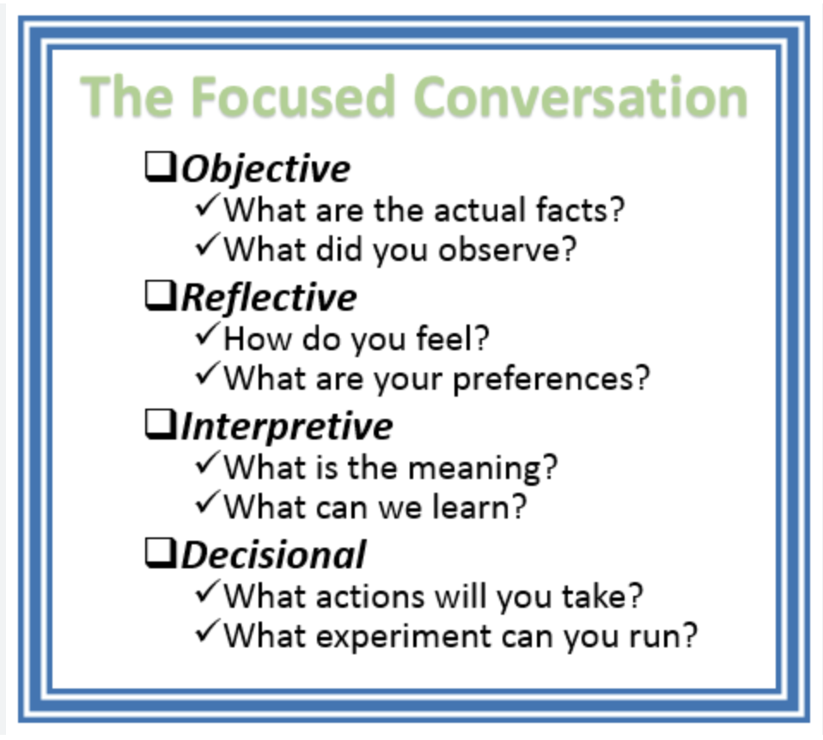

ORID Protocol Notes
Objective
Reflective
Interpretive
Decisional

