Participant’s Guide

Episode 22

Race Relations: Crossing the Divide

Summary

There are great advantages to serving the Lord alongside others of different ethnicities who have different life experiences and different perspectives than we have. Jesus prayed in John 17 for His followers, “that they may all be one… so that the world may believe that You have sent Me” (John 17:21, NASB). How can we overcome our unconscious biases and celebrate the brotherhood we enjoy when walking with Jesus in unity?

Speaker
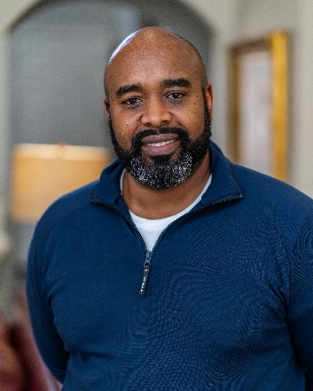
Dr. Omari Hodge is the Program Director for a family medicine residency in Tampa, FL. He and his wife Kiera have been married for 25 years and have four children. Currently, he serves on the CMDA Board of Trustees. Additionally, he chairs CMDA’s R²ED Committee and an advisory panel to the board on issues of race and reconciliation. He and his wife enjoy traveling, doing missionary work, and experiencing different cultures. In their spare time, you can find them hiking, biking, or checking out local eateries around the Tampa area. For further information or to contact Dr. Omari Hodge, email him at Omsyki@gmail.com.

Discussion Questions

- What from this video inspired, edified or challenged you?

- In seeking better race relations, Dr. Hodge exhorts us to seek not just diversity but also cross-cultural dependency.
- How does this second step accomplish more than just the first?
- Is cross-cultural dependency a biblical goal? (Hint: see 1 Corinthians 12:12-21.)

- Jaime Saint says, “We believe that God has gifted every Christ follower in unique ways for meaningful participation in His Great Commission.” How does this reality inspire us toward pursuing diversity and cross-cultural dependency?

- Dr. Hodge says, “You really can’t appreciate the fullness of Christ until you begin to see Him through the lens of other people.”

- Why might this be so?
- Any examples of things you have learned about Christ or the gospel from people ethnically or culturally different from yourself?

- Revelation 7:9-10 says, “After this I looked, and behold, a great multitude that no one could number, from every nation, from all tribes and peoples and languages, standing before the throne and before the Lamb, clothed in white robes, with palm branches in their hands, and crying out with a loud voice, ‘Salvation belongs to our God who sits on the throne, and to the Lamb!’” (ESV). How might this passage inspire you to pursue better race relations in your community?
6. Dr. Hodge states, “Loving cross-culturally can be one of the biggest evangelistic tools that we have at our disposal.” Why might this be? Relate this to John 17:20-23.
7. How might the following Bible passages move us toward greater solidarity with those who are different from us?
- “Know this, my beloved brothers: let every person be quick to hear, slow to speak, slow to anger; for the anger of man does not produce the righteousness of God” (James 1:19-20, ESV).
- “But the Lord said to Samuel, ‘Do not look on his appearance or on the height of his stature, because I have rejected him. For the Lord sees not as man sees: man looks on the outward appearance, but the Lord looks on the heart’” (1 Samuel 16:7, ESV).
- “There is neither Jew nor Gentile, neither slave nor free, nor is there male and female, for you are all one in Christ Jesus” (Galatians 3:28, NIV).
- “All the ways of a man are pure in his own eyes, but the Lord weighs the spirit” (Proverbs 16:2, ESV).
8. Dr. Regina Frost is transparent in admitting that we all have subtle conscious and subconscious prejudices toward our patients and others. What are some ways in which a fuller experience of the gospel can help us alleviate prejudicial attitudes?
9. What is one take-home item from today’s session that you hope to implement?

Additional Resources

- Confronting Injustice without Compromising Truth: 12 Questions Christians Should Ask About Social Justice by Thaddeus J. Williams and John M. Perkins

