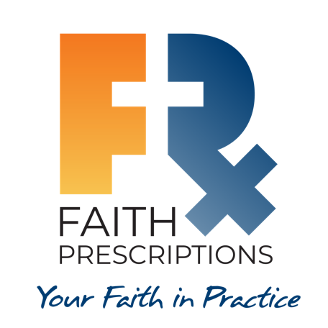
Participant’s Guide

Episode 17

The Case for Practicing Medicine Christianly – Part 2

Summary

Of all the ways Jesus could have demonstrated His power, the most frequent display was through healing. He also commanded His disciples to go out for the purposes of preaching and healing, linking these two together in a way that should make us want to go and do likewise. Overall health must include spiritual health, or else the benefits will be short-lived. There are many demonstrable benefits for those of our patients who are walking with Jesus, and we can help our patients more fully appreciate the physical blessings connected with spiritual health.

Speaker

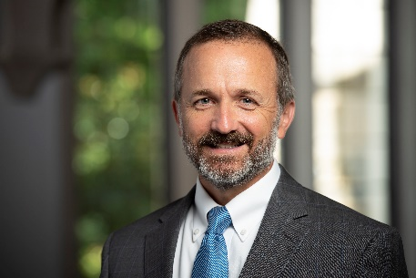
Farr Curlin, MD, is the Trent Professor of Medical Humanities and Co-Director of the Theology, Medicine, and Culture Initiative (TMC) at Duke University. Dr. Curlin’s ethics scholarship takes up moral questions that are raised by religion-associated differences in physicians’ practices. He is an active palliative medicine physician and holds appointments in both the School of Medicine and the Divinity School, where he and colleagues offer Christian theological formation to those with vocations to healthcare.

Discussion Questions

1. What from this video inspired, edified or challenged you?

2. During the course of your study of the Faith Prescriptions resource, has your ability to address your patients’ spiritual needs increased? What changes have you seen?

3. Dr. Curlin makes a strong case for integrating our personal (spiritual) and professional lives, and for viewing all patients and colleagues as spiritual beings. How do the following Scriptures speak to his points?

- Luke 9:2

- Matthew 9:1-8

- Matthew 25:34-40

4. Dr. Curlin states regarding the practice of medicine, “We should make use of it, it’s a gift of God, but don’t put our hope in it, as if it is the physician who saves.” See if you can create a statement to a patient that would communicate this reality to a patient in a way that honors Christ. (Perhaps give each participant time to create a statement, then allow multiple people to read what they came up with).

5. Do you believe the overall health of a patient includes their spiritual health? If so, what are some ways you demonstrate this belief to your patients?

6. Dr. Curlin states, “We don’t treat the profession of science as somehow self-vindicating, as somehow beyond critique. Science does not give us direction about how to use technology.”

a. Why might some believe science is self-vindicating?

b. What are some examples of how medical science, in the absence of proper moral grounding, has progressed in ways that make immorality more prevalent?

7. Dr. Harold Koenig states, “People who are a part of a faith community, people who attend religious services regularly, have enormous health benefits from that…And that gives physicians a really good reason for encouraging patients to engage in their faith community.” Have you ever shared with patients the empirical benefits of religious involvement? Why or why not?

8. What is one take-home item from today’s session that you hope to implement?

Additional Resources

- Curlin FA, Hall DE. Strangers or friends? A proposal for a new spirituality-in-medicine ethic. J Gen Intern Med. 2005;20(4):370-374
- Curlin FA, Tollefsen C. Conscience and the way of medicine. Perspect Biol Med. 2019;62(3):560-575
- Curlin FA, Tollefsen C. The Way of Medicine. Ethics and the Healing Profession. Notre Dame University Press (forthcoming 2021)
- Grace Prescriptions, Module 2 – Are Spiritual Interventions Appropriate in Clinical Care?
- Grace Prescriptions, Module 3 – The Case For Spiritual Interventions.

