Participant’s Guide

Episode 13
Addiction and The Good News

Summary

Addiction treatment can be one of the most trying aspects of healthcare. The temporary euphoria of a drug-induced high can make one oblivious to the long-term damage that is occurring. Yet, so often it is through weakness that people come to know, or grow in, their relationship with Christ. God can use our efforts to unleash the power of the gospel in the lives of our patients.

Speaker
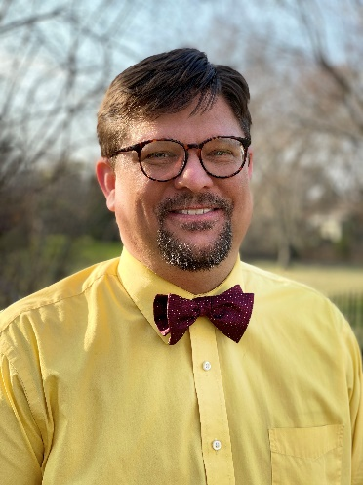
Timothy Allen, MD, and his wife Nikki Allen, MD, view themselves as missionaries to Cudahy, Wisconsin, an economically depressed suburb of Milwaukee. They run an independent clinic that provides general medical, addiction and psychiatric care focusing on those whom society often ignores. As part of their ministry, they are involved in a church plant that currently meets in their waiting room on Sunday mornings. He and his wife have been involved with CMDA since medical school, have been married since 2000 and have four children and one grandchild. For further information or to contact Dr. Tim, email him at timothyallenmd@gmail.com.

Discussion Questions

- What from this video inspired, edified or challenged you?

- Jesus said that our patients will know we are followers of Christ by our love in John 13:34-35. What might that love look like to patients battling drug addiction?

- Dr. Allen makes the point that patients who are addicted (and other patients as well) need to feel that they have value as human beings. How could Genesis 1:26 and Ephesians 2:10 be used to help patients know they have value?

- How can we help people with addiction find something better? See Romans 6:21, Ephesians 4:22-24a and Galatians 5:19-22.

- Dr. Allen notes that patients who have a spiritual transformation are those most likely to overcome an addiction (92 percent success rate). How might Romans 8:1-2, Romans 5:1-2 and 1 Corinthians 6:19-20 be useful in talking to patients about their relationship with God?

- Do you have any underlying biases against treating addiction that could interfere with showing God’s love with those who struggle? Drs. Karl Benzio and Val Tramonte speak of the fact that we all struggle in various ways. How can this fact equip us to deal with any underlying biases against caring for our addiction patients?

- When Dr. Allen’s patient asked him, “What the bleep is wrong with you?”, how does this illustrate a principle from 1 Peter 3:15?

- What is one take-home item from today’s session that you hope to implement?

Additional Resources

- www.asam.org
- www.celebraterecovery.com
- www.samhsa.gov

