Participant’s Guide

Episode 3
Keeping It Natural

Summary

Interactions with our patients will be richer and deeper if we let our lights shine through our practices. It’s not just for the benefit of our patients; it also frees us up when we realize that the Gospel equips us to share God’s grace with others.

Speaker

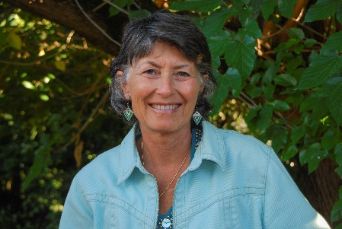
Patti Francis, MD, joined CMDA as a first-year medical student and has stayed involved ever since! She is in private practice in pediatrics in the San Francisco Bay Area since 1985. She has been married to Ron for over 40 years and has two adult daughters. She loves the outdoors and working with women physicians in CMDA. Dr. Francis may be contacted at gohikingwithpatti@comcast.net.

Discussion Questions

- What from this video inspired, edified or challenged you?

- What does it mean from John 15:5 to “abide in Christ?” Is “abiding in Christ” necessary in order to communicate the gospel? Why or why not?

- When might be a good time for a faith flag? For a faith story? For a faith prescription?

- Regarding Matthew 10:14, why do you believe Jesus communicated this wisdom to His followers? How does it speak to us as we seek to share the love of Christ with our patients?

- Do you ever pray with your staff? Why or why not?

- Dr. Bobbie Sperry gave us some examples of non-verbal faith flags. Are these a part of your spiritual interventions? How could they be?

- Dr. Karl Benzio states, “You have this incredible natural opportunity to ask them questions that nobody else can ask them.” Is this an instrument in your spiritual toolbox?

- What is one take-home item from today’s session that you hope to implement?

Additional Resources

- Experiencing God by Henry Blackabee
- Practicing the Presence of God by Brother Lawrence
- Winning the War in Your Mind: Change Your Thinking, Change Your Life by Craig Groeschel

