Leader’s Guide

Episode 7
Praying With and For Our Patients

Summary

If we believe in the power of prayer, and if we pray regularly, there are excellent reasons to continue this wonderful habit into our patient interactions. The Lord can work through prayer in healthcare to bless both the patient and the caregiver. Various aspects of praying with and for patients are considered including why, when, how to and how to document, along with some delightful examples.

Speaker
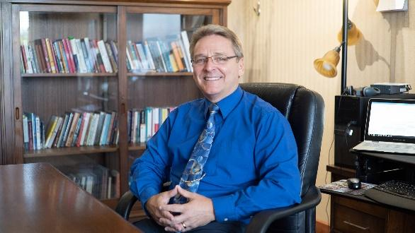
Mike Chupp, MD, FACS, is a board certified general surgeon and a Fellow of the American College of Surgeons who spent most of his clinical career as a missionary general and orthopedic surgeon at Tenwek Hospital in Southwest Kenya. He also enjoyed nearly seven years of private practice as a surgeon partner of Southwestern Medical Clinic, a large Christian multispecialty practice in Berrien County, Michigan. In 2016, Mike joined the executive leadership team of CMDA as the Executive Vice President, joining then CEO Dr. David Stevens. The CMDA Board of Trustees appointed Dr. Chupp to be Dr. Stevens’ successor and CEO of CMDA in late 2018, a position he has held since September 2019.

Discussion Questions

- What from this video inspired, edified or challenged you?

- Are you currently praying with or for your patients? If so, under what circumstances does this usually happen?

Some have regular times when they offer to pray for their patients, such as at their first appointment, before surgery, after washing one’s hands in preparation for treatment (Dr. Chupp’s example), etc. In addition, episodic opportunities also arise, such as being related to a hard diagnosis, an upcoming medical test or perhaps a crisis not related to medical care. Hopefully, participants will offer personal examples from their patient interactions.

- What are some of the ways God works through our prayers for our patients?

Dr. Chupp’s four items:

- Prayer demonstrates that we care.
- Prayer humbles us.
- Prayer can relieve anxiety (the patient’s AND the doctor’s).
- Praying with patients paves the way for future spiritual interactions.

- How can clinicians appropriately pray with patients without offending them or violating ethical standards?

- P — Prepare your heart for the opportunities
- R — Respectfully
- A — Ask prior to praying for someone
- Y— Yield to the wishes of the patient

We need to respectfully ask the patient if they would be agreeable to us praying for them, and then yield to their response. Of course, they cannot stop us from praying for them, but we would just refrain from doing so out loud.

- What are potential responses from patients or family members when you respectfully offer to pray?

The hope with this discussion would be that if we respect our patients, their response to our offer to pray is far more likely to be positive than negative. Also, even if it is negative, this can be a “pebble in their shoe” to cause them to reconsider their rejection of our spiritual intervention.

- Dr. Sherry-Ann Brown states, “Anything that happens in a visit ought to be documented. So, I might write, ‘Prayer is important to this patient, prayer was offered and received and seemed to bring her comfort.’” Do you document prayer in a patient’s chart? Why or why not?

Healthcare professionals might be afraid of recording their opportunities to pray with patients, perhaps due to fear that spiritual interventions would be seen as unnecessary or offensive. However, if we offer prayer with sensitivity and respect, asking permission, then the burden of proof is on the one who denies the appropriateness of action. Many studies have confirmed the therapeutic benefit of spiritual interventions, and we have both God and empirical evidence on our side when we pray with and for patients (see item #3 below under Additional Resources). Documenting this action in the chart is a step toward making our notes more complete, and it just might influence other healthcare professionals to go and do likewise.

- What steps could you take to make prayer for your patients a more regular occurrence?

Schedule times to pray for them, perhaps at the beginning of the day (as does Dr. Tim Allen in Milwaukee, Wisconsin), or perhaps at the end of the day on the way home from work. Also, perhaps enlist another healthcare professional in your office to be available to pray with patients, especially when time is tight.

- Dr. Malieka Johnson speaks of how the Lord can relieve anxiety through prayer (Philippians 4:6-7). What are some reasons why prayer can be so effective in relieving anxiety?

Prayer reminds us that the ultimate outcomes are in the hands of the Lord, and it relieves us of the false pressure to control all outcomes. Prayer can also enable patients to recognize the hand of the Lord in their lives, controlling all circumstances for the good of His people. In addition, the Lord can work supernaturally through prayer in ways beyond our ability to fully understand.

- What is one take-home item from today’s session that you hope to implement?

Additional Resources

- Curlin, FA, Sellergren, SA, Lantos, JD, et al. Physicians’ Observations and Interpretations of the Influence of Religion and Spirituality on Health. Archives of Internal Medicine. 2007(Apr);167(7):649-654.
- Berlinger, N. Quoted in: O’Reilly, KB. When a patient visit includes a request for prayer. AMA News, June 11, 2012.
- Koenig, HG. Religion, Spirituality, and Health: The Research and Clinical Implications. ISRN Psychiatry. 2012, Article ID 278730.

