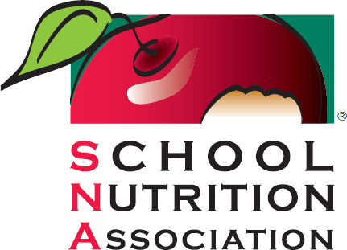

SNA SPEAKER AGREEMENT FORM

The following form submission will be used to ensure your information is accurate in SNA’s promotion of your session.

Speaker Name:
Speaker Credentials (example: RD, SNS):
Professional Title:
Company/ School District Name:
Email:
Cell (internal use only):
Office Number (internal use only):
Business Website:

- I agree to present the session at SNA’s Annual National Conference 2023 (ANC). I will address the title and topic information as specified.
- I understand that my presentation may also be held virtually on SNA’s virtual platform. This may require me and my panelists to schedule a pre-recording with assigned SNA team members, unless otherwise specified. In addition, I will be available for live chat on the platform at the date and time of my scheduled presentation.

- I understand that in order to provide the participants with electronic handouts for the session, I will need to comply with the submission deadlines and requirements listed.

- During my presentation, I will not engage in any type of promotional marketing, selling of any product(s) or service(s), promote virtual exhibit booth(s) or distribute any prizes, products, merchandise.

- I agree to notify SNA immediately in the event that an emergency should prevent me from presenting.

- I warrant and represent that, to the best of my knowledge, nothing in my presentation violates any proprietary or personal rights of others, is factually accurate, and contains nothing unlawful.

- I further warrant and represent that my presentation is my own original work, I have obtained all necessary permissions or licenses from any persons or organizations whose material is included or used in my presentation.

- I authorize SNA to use my name, likeness, photograph, and biographical data in connection with the use of promotion of the conference and my presentation.

- I understand that SNA offers industry members the opportunity to sponsor different components of conferences, including but not limited to education session tracks and general sessions. I am aware that my education session could be placed within a sponsored education session track, or covered in an executive summary sponsored by an industry member. I also understand that SNA clearly communicates to all attendees that meeting sponsorships, products, services, or expressed ideas do not constitute endorsement or recommendation by SNA or the presenter.

- Changes to submitted presentations may not be made without first communicating said changes to SNA.

- SNA may record the speaker’s live presentation.

- Speakers agree that the presentation and recording of presentation becomes the property of SNA and may be shared in the presentation library on the SNA website and archived for future use.

- Speakers must be granted permission from SNA to record their own presentation by Waiver. If granted permission, the speaker agrees that the recording is for personal use only. The recorded product cannot be distributed on social media or shared for marketing or commercial purposes. The presenter will be responsible for making the audience aware of the recording, even if the audience is not featured in the recording and allow them the option to opt-out. The recorder will not capture audience members purposefully and will remove their likeness in post-production.

- For PowerPoint presentations, no company logos may be used unless mutually agreed by SNA.

- By signing this agreement, I agree to follow the SNA Presentations Guidelines.

- I agree to complete SNA’s disclosure agreement and to disclose any affiliations or financial relationships with commercial industry organizations during the last 12 months as they pertain to my presentation.

- Educational sessions, Ideas@work sessions and Learning Bursts are open to all attendees, including media. Any concerns about media being present during my presentation should be directed to media@schoolnutrition.org by April 1, 2023.

- SNA reserves the right to stop any presentation that violates the conditions set forth in this agreement.

By signing SNA’s Speaker Agreement, and based on mutual consideration, I hereby understand and agree to the above conditions as listed.

Signature
Date _

Disclosure Statement
The School Nutrition Association (SNA) is an accredited provider of continuing professional education. The purpose of the Disclosure Statement is to collect potential conflicts of interest to notify SNA members including School Nutrition Professionals, School Nutrition Specialists (SNS), Registered Dietitians (RD), and Dietetic Technicians, Registered (DTR).

What to disclose: Financial relationships with a Corporate Industry Organization that may include salary, grants/research support, consulting fees, stock shareholder honoraria, or other financial and material support, within the last 12 months.

Please choose only one of the following statements.

Disclosures must be included in a slide as part of your presentation, as reflected in the PPT template that SNA will provide.

I have nothing to disclose. Neither I nor any member of my immediate family have any relevant financial relationships with any commercial industry organizations associated with my presentation(s).
◻

I have the following relevant financial relationship(s) to disclose:

Affiliation / Financial Relationships Organization
Employee
Grants / Research Consultant
Stock Shareholder Honorarium

Other Financial and Material Support

While an affiliation or financial relationship with a Corporate Industry Organization does not prevent you from making a presentation, the relationship must be made know to attendees. Failure to complete this form will preclude you from presenting.

Print Name Title

Signature Date

SNA Meetings Presentation Guidelines
The purpose of this document is to outline policies and procedures for presentation materials presented or distributed at SNA meetings, conferences and events. Should you have any questions, please contact education@schoolnutrition.org

Section I: Formatting
SNA outlines the following guidelines in an effort to have a cohesive look and feel to our meetings:
- SNA meetings/conferences have a specific branded template. Speakers are required to use this template unless otherwise agreed upon with SNA.
- If there are multiple presenters, the presentation should be merged into one document.
- The first slide or page of the presentation should include: Session Title, Date, and Time; Presenter(s) name(s), title, company
- To encourage practical use of content, learning objectives must be clearly outlined prior to beginning the content.

Section II: Visual Aids
To help engage the audience, presenters are encouraged to use images and visual aids to reinforce learning.
- Speakers should ensure that no images used are copyrighted or intellectual property of another person, company, organization or entity.
- Proper citation and credit are to be provided to originating source when using images, data or examples from other organizations or speakers.
- Presenters should avoid using images that contradict the mission of SNA. This includes images of fast food, unhealthy options, or other images that contradict the importance of providing healthy, nutritious meals to students.

Section III: Marketing and Branding
As a member driven organization, SNA must be careful to avoid conflicts of interest with commercial entities. Therefore, in cases where an education session is presented by an industry group, organization, consultant, or entity that has a potential conflict of interest, the policy below must be followed:
- SNA does not permit merchandise, products, self-promotion, food samples, food- tasting, live culinary demonstrations, or advertisements during any education sessions

at any SNA meetings. Any exceptions are at the sole discretion of SNA.
- The presentation cannot promote any brand, company, or product.
- If using images of the organization’s product images, at least 2 other competing
brands are required to be included in the presentation to avoid conflicts of interest.
- For PowerPoint Presentations, no company logos may be used unless mutually agreed by SNA to allow the logo on the first and last page.
- A disclosure slide must be included immediately after the title slide. Sample disclosure slides are provided below. All items mentioned in the speaker’s signed written disclosure must be included on this slide.
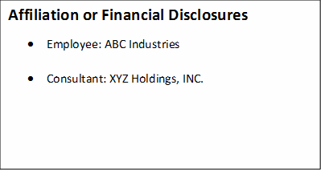
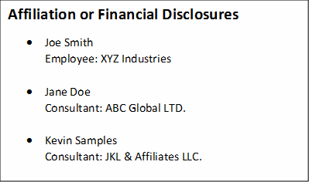

Section IV: Miscellaneous
  - Presentations cannot include statements or images that contradict or damages SNA’s image, mission statement and code of ethics, including but not limited to its members and affiliates.
  - Presentations must be submitted a minimum of 4 weeks prior to the event.

Bio & Headshot Request
Along with the speaker agreement and disclosure above, please submit bio and headshot on the Call for Proposal Wesbite. The bio will be submitted to the Commission of Dietetic Registration so SNIC dietitian attendees can receive CPEU credit for their participation. It will also be used in your profile on the conference app. The headshot may be used on the SNA website, email and social media promotional material, and will be used for your profile on the conference app.

Bio: In paragraph form, elaborate on the following subjects:  - Name  - Schools that you have attended.  - Relevant certifications  - Relevant qualifications  - Distinguishing awards  - Field related associations  - Relevant work experience (include positions and years) | Headshot:  - Jpeg, or png file  - Size 300x300 px or larger  - Head neck and shoulders in frame  - Head not cut off at top of image  - Rectangular or square is fine, but if it is rectangular, make sure there is space around you, to allow for cropping.  Example:

