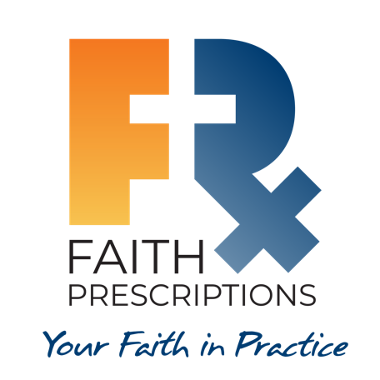
Participant’s Guide

Episode 23

For Educators: Equipping Students And Residents

Summary

It is a great privilege to be able to positively influence the next generation of healthcare professionals. Those who instruct students and residents seek to equip them with the knowledge and the heart to treat patients with skill and compassion. Educators who walk with Jesus are uniquely gifted to speak into the lives of students during their training years. The difficulties encountered during this formative period of instruction can be used by the Lord to create caregivers who promote healing of both body and soul.

Speaker
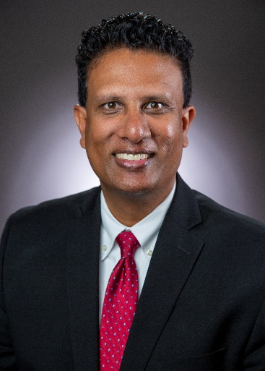
Dr. Francis Nuthalapaty is a Maternal-Fetal Medicine physician and Obstetrics and Gynecology Residency Program Director at the Northeast Georgia Medical Center in Gainesville, GA. He became a committed Christ follower during his fellowship and is sensitive to the power of the Gospel in training environments. He and his wife Elizabeth have three children. For further information or to contact Dr. Nuthalapaty, email him at fsn@nuthalapaty.net.

Discussion Questions

- What from this video inspired, edified or challenged you?

- Dr. Nuthalapaty speaks of encountering doctors during his medical school years who “just seemed so unhappy…it seemed like they wanted to be somewhere else, they didn’t enjoy what they were doing.” What are some of the factors that can contribute to our overall career contentment in healthcare? See Colossians 3:23, Psalm 90:17 and 2 Corinthians 4:18.

- Three simple and practical recommendations are mentioned to help educators engage with healthcare trainees:

  - Be authentic.
  - Make your home a sanctuary.
  - Learn about the students.

How can each of these steps positively affect the personal and professional development of the students?

- Dr. Cathie Scarbrough references how residency is a crucial time when residents might be inclined to either give up their faith, or they can “embrace spiritual care and whole person medicine and run after that for the rest of their careers.”

- What factors could lead to a healthcare student or resident falling away from the Christian faith?

- Conversely, how might the training years serve as a time of spiritual growth and maturity?

- Dr. Laurie Tam speaks of how those students who participate with their CMDA communities can develop habits during their training to enable them to thrive through residency and beyond. What are some examples of good habits that can assist us in our training years and beyond? (Hint: Dr. Jonathan Tsai mentioned one.)

- Dr. Nuthalapaty shares his wonderful story of a medical student who came to faith in Christ, and dental student Liz Flaherty describes the opportunity students have to plant gospel seeds during their training years. Do you know of anyone who came to faith, or grew in faith, during their professional training? What might contribute to the gospel taking root in the heart of a healthcare student?

- It was a mission trip with CMDA’s Global Health Outreach that introduced Dr. Nuthalapaty to the joy of the gospel. How have your efforts to treat the needy, either domestically or internationally, affected your walk with Jesus?

- What is one take-home item from today’s session that you hope to implement?

Additional Resources

- Living in the Lab Without Smelling Like a Cadaver by William C. Peel, ThM
- Jesus, MD by David Stevens, MD
- What I Learned about God in Medical School by Troy Vines, MD

