What we know about Principal Leadership
“Culture, like trust, must start on day one, takes years to build, and only a few seconds to lose.”

Systems can often remain untouched through the constant change of leadership.”

“Without a positive school culture, and systems to support that culture, historically inequitable gaps will persist.”
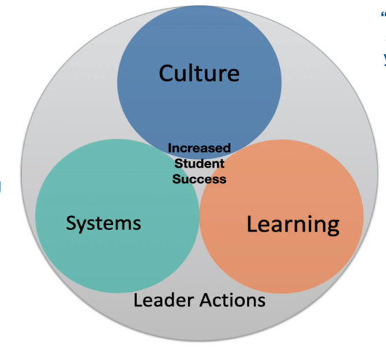
Lead by creating CULTURE

Lead by building SYSTEMS

Lead by leading LEARNING

Reflecting on your own leadership...respond to the following prompts:
How did you lead?

Where did you start?

What worked?
What didn’t work?

What specific actions, successes, and challenges in each of the domains did you experience?

Strategies for Reducing Principal Turnover
- Providing high-quality professional learning opportunities
- Improving working conditions
- Ensuring adequate and stable compensation
- Supporting decision-making authority in school leadership
- Reforming accountability systems

AWSP Theory of Action
If we align and improve the consistency of statewide systems that prepare and
support principals, then we can accelerate and improve the effectiveness
and sustainability of principals in our state.

