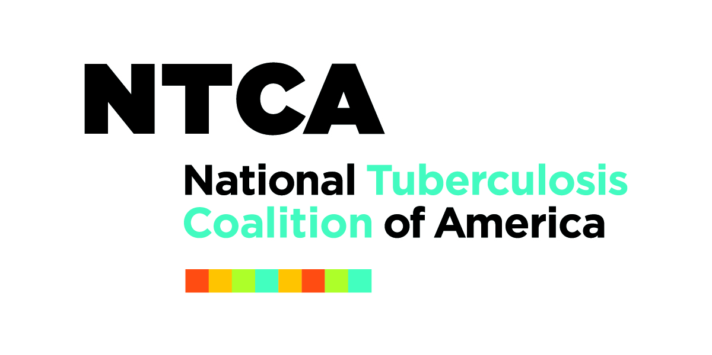

NTCA/NTNC Webinar Resources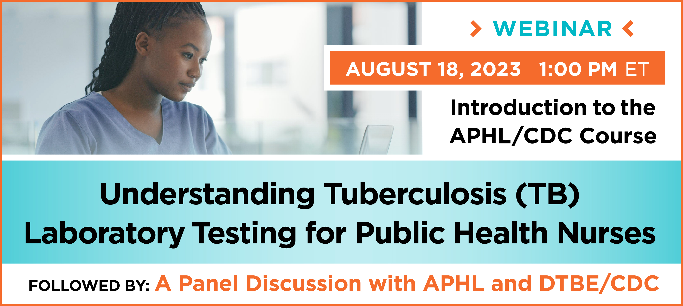

- Link to APHL on-line course “Understanding Tuberculosis (TB) Laboratory Testing for Public Health Nurses https://www.aphl.org/programs/infectious_disease/tuberculosis/Understanding_TB_Lab_Test_Nurses/story.html

- Guidelines for Submission of Sputum Specimens for Tuberculosis Testing – April 2018 https://www.aphl.org/aboutAPHL/publications/Documents/ID-2018Apr-Guidelines-TB-Sputum-Submission.pdf

- MDDR User Guide: Molecular Detection of Drug Resistance (MDDR) in Mybcobacterium Tuberculosis Complex by DNA sequencing (Version 3.0) – February 2023 https://www.cdc.gov/tb/topic/laboratory/mddr-user-guide.htm

- Association of Public Health Laboratories TB Resources Page https://www.aphl.org/programs/infectious_disease/tuberculosis/Documents/

- Link to google search with TB Lab Resources – cut and paste this link into your web browser https://www.aphl.org/programs/infectious_disease/tuberculosis/Pages/Training-Modules.aspx.

