Participant’s Guide

Episode 7
Praying With and For Our Patients

Summary

If we believe in the power of prayer, and if we pray regularly, there are excellent reasons to continue this wonderful habit into our patient interactions. The Lord can work through prayer in healthcare to bless both the patient and the caregiver. Various aspects of praying with and for patients are considered including why, when, how to, and how to document, along with some delightful examples.

Speaker

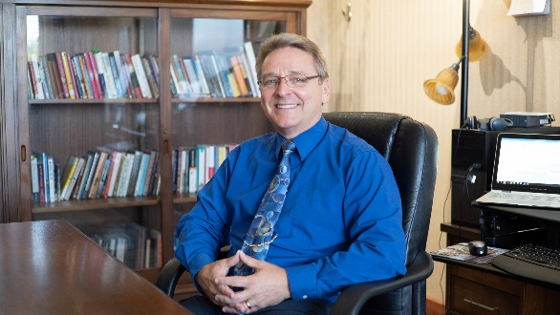
Dr. Michael E. Chupp is a board-certified general surgeon and a Fellow of the American College of Surgeons who spent most of his clinical career as a missionary general and orthopedic surgeon at Tenwek Hospital in Southwest Kenya. He also enjoyed nearly seven years of private practice as a surgeon partner of Southwestern Medical Clinic, a large Christian multispecialty practice in Berrien County, Michigan. In 2016, Mike joined the Executive leadership team of the CMDA national ministry as the Executive Vice President, joining then CEO, Dr. David Stevens. The CMDA Board of Trustees appointed Dr. Chupp to be Dr. Stevens’ successor and CEO of CDMA in late 2018, a position he has held since September 2019.

Discussion Questions

- What from this video inspired, edified or challenged you?

- Are you currently praying with or for your patients? If so, under what circumstances does this usually happen?

- What are some of the ways God works through our prayers for our patients?

- How can clinicians appropriately pray with patients without offending them or violating ethical standards?

- What are potential responses from patients or family members when you respectfully offer to pray?

- Dr. Sherry-Ann Brown states, “Anything that happens in a visit ought to be documented. So, I might write, ‘Prayer is important to this patient, prayer was offered and received and seemed to bring her comfort.’” Do you document prayer in a patient’s chart? Why or why not?

- What steps could you take to make prayer for your patients a more regular occurrence?

- Dr. Malieka Johnson speaks of how the Lord can relieve anxiety through prayer (Philippians 4:6-7). What are some reasons why prayer can be so effective in relieving anxiety?

- What is one take-home item from today’s session that you hope to implement?

Additional Resources

- Curlin, FA, Sellergren, SA, Lantos, JD, et al. Physicians’ Observations and Interpretations of the Influence of Religion and Spirituality on Health. Archives of Internal Medicine. 2007(Apr);167(7):649-654.
- Berlinger, N. Quoted in: O’Reilly, KB. When a patient visit includes a request for prayer. AMA News, June 11, 2012.
- Koenig, HG. Religion, Spirituality, and Health: The Research and Clinical Implications. ISRN Psychiatry. 2012, Article ID 278730.

