Biography: Scott Pasternak
Solid Waste and Resource Recovery Consulting
Burns & McDonnell

Current Position
Scott leads the Texas Solid Waste and Resource Recovery consulting practice for Burns & McDonnell

Prior Experience and Education
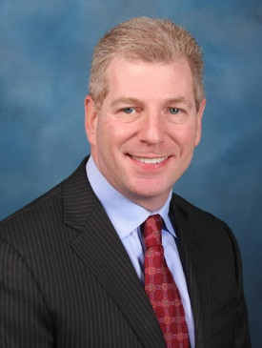
Mr. Scott Pasternak is an Associate and Senior Project Manager for the Solid Waste and Resource Recovery Practice for Burns & McDonnell, which focuses on advancing the solid waste and recycling programs for governmental entities. He managed the Study on the Economic Impacts of Recycling for the TCEQ. Since the 1990s he has focused his career on working with clients to solve challenging technical and financial solid waste management and recycling issues. Geographically, he has worked for local, regional and state governments in 20 states. From 1995-2000, he was a solid waste planner for the Texas Commission on Environmental Quality, where he assisted in developing the statewide solid waste strategic plan and annual report. He holds a Masters’ of Science in Community and Regional Planning and Bachelor of Arts with Honors, both from the University of Texas. He is the Director for SWANA’s Planning and Management Technical Division and serves on the Municipal Solid Waste and Resource Recovery Advisory Council for the State of Texas.

Contact Information
Telephone: (512) 589-3411
E-mail: spasternak@burnsmcd.com

