Collaborative Engagement Project:
Addressing the Ongoing Impacts of the Covid-19 Pandemic on K-12
in Washington State

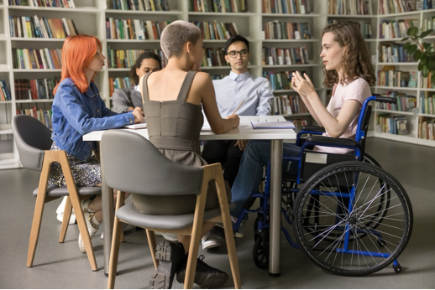

Background
This project builds on the Ongoing Impacts of the Covid-19 Pandemic on K-12 in Washington State Final Report, which drew on 75 interviews with teachers, students, administrators, and community members. That work highlighted ongoing challenges and promising practices for supporting children’s academic, social, and emotional recovery from the pandemic.

Purpose
To convene administrators, educators, and students to enhance dialogue, learning and sharing of promising practices at the Peninsula School District to support the recovery of the district’s children and youth from the ongoing social, emotional, and academic impacts of the Covid-19 pandemic.

Project description
The project seeks to focus attention to ongoing pandemic impacts on children and the K-12 system and renew participants’ commitment to addressing recovery through the following kinds of activities:
- Explore promising practices that are helping children and youth thrive academically, socially, and emotionally, as well as those supporting caregivers, educators, and administrators.
- Share challenges and lessons learned across districts and communities.
- Identify successful approaches and opportunities for collaboration to support mental health, belonging, and academic achievement.
- Generate practical ideas and commitments participants can take back to their schools and organizations.

Planned Convenings
- Yakima (ESD 105), October 2025
- Gig Harbor (Peninsula School District), November 2025
- Association of Washington State Principals, November 2025

For more information contact: phyllis.shulman@wsu.edu and/or tye.ferrell@wsu.edu

Association of Washington School Principals Webinar Agenda, November 19, 2025
Building Stronger Schools: Lessons and Partnerships Post-Pandemic
4:00pm-5:30pm
Session Goals:
- Engage Washington school principals and assistant principals in dialogue about the impact and lesson learned from Covid-19.
- Share and explore which practices are working to address the ongoing impacts of the pandemic on students, staff, and families.
- Identify what is needed, especially for principals and assistant principals to more fully address the impacts, including new partnerships or collaborations that could be helpful, and potential action steps.
Agenda (90 minutes)
Purpose: To inform current efforts to address the ongoing pandemic impacts and share ideas to further address the impacts.
Time | Topic
10 min. | Welcome, introductions, and initial question.
10 min.  10 min.  25 min.  20 min.  10 min.  5 min. | Presentation: Overview of report findings and recommendations.  (Participants will receive a short summary in advance.)  Sharing key themes discussed in the previous two convenings: in Yakima with school administrators and in Gig Harbor with high school students.  Small group discussions: What do you need as principals and assistant principals to more fully address the ongoing impacts of the pandemic to meet the needs of students and staff? What is needed for those students and staff where efforts are not working well?  Report out from small groups.  Identify any next steps.  Reflections

