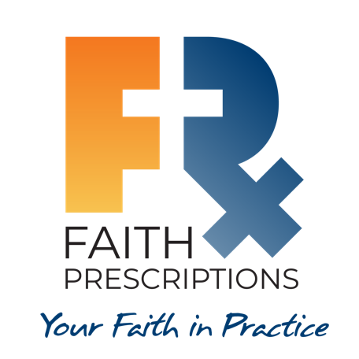
Participant’s Guide

Episode 5
Spiritual Interventions

Summary

Medical evangelism is a natural overflow of who we are in Christ. We communicate to our patients the Good News with respect, sensitivity and permission, metering the dose based on where they are in their spiritual journey and thereby seeking to bring them one step closer to Jesus.

Speaker
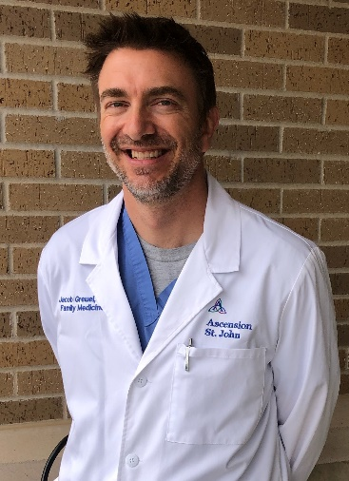
Dr. Jacob Greuel was raised in church, but as a young adult faltered until he had an encounter with God during medical school that dramatically altered the course of his life. While in family medicine residency, a faculty member led he and others through CMDA’s Saline Solution. Subsequently, sharing the love of Christ became paramount in his Alabama private practice. Then he and his wife realized a call beyond that practice and short-term missions to “multiply medical ministry”. To that end, he completed a fellowship in obstetrics and currently serves on the faculty at In His Image Family Medicine Residency Program in Tulsa, Oklahoma. Dr. Greuel is passionate about training others to magnify the Lord, especially through the practice of medicine. He also enjoys being active in the outdoors and spending time with his wife and their four sons. Dr. Greuel can be contacted at greueljv@yahoo.com.

Discussion Questions

- What from this video inspired, edified or challenged you?

- John 1:14 says Jesus was “…full of grace and truth” (ESV), and Dr. Greuel calls us to exude these same two attributes in sharing the gospel. If our proclamation of the Good News is lacking in grace, how is it likely to be received? How about if it is lacking in truth?

- In the agrarian model of evangelism, which of the following seems most natural for you: cultivating, sowing, harvesting or multiplying? Which do you find the most challenging?

- Why are respect, sensitivity and permission so important when talking with patients regarding spiritual things?

- Dr. Katie Musser speaks of her treatment of a denture patient and how it took a year for the patient to express an interest in the Bible. What are some factors in how we treat our patients that could eventually contribute to their eventual desire to know more about what the Bible says?

- Dr. Greuel stated in closing. “Medical evangelism is a natural overflow of who we are in Christ.” He also describes the idea of partnering with God in what He is doing in a person. As you think about these ideas, in light of the material we’ve seen so far in this series, do you feel like you are coming from a place where your actions could be described this way?

- Think of someone in your life you would like to see come to Christ. Using the ideas covered in this segment, how could you specifically help them take one step closer to Christ?

- What is one take-home item from today’s session that you hope to implement?

Additional Resources

- Your Best Life in Jesus’ Easy Yoke by Bill Gaultiere, PhD
- The Saving Life of Christ by Major W. Ian Thomas
- Don’t Waste Your Life by John Piper
- I Once Was Lost by Don Everts and Doug Schaupp

