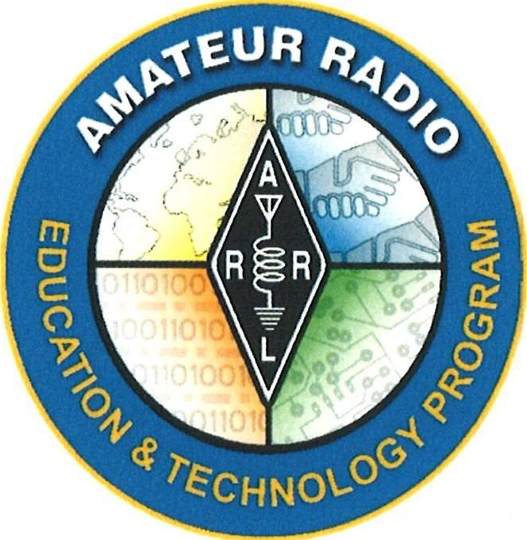

**Electronics Curriculum Prepared for ARRL Education & Technology Program Grade Level: 6 - 8**

Revised Draft

June 2023

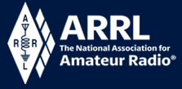

**Electronics Course Table of Contents**

|  |  |  |
| --- | --- | --- |
| Day 1 | Intro to Electronics | Where are electronics used today?  Difference between electricity and electronics  Magnet Drop Demo etc. |
| Day 2 | Direct Current and  DC Circuits | Voltage and Current  (Intro VOM, measure batteries)  Electricity and Magnetism (Monopolar Motor) |
| Day 3 | Capacitors and Inductors | (Est. 2 day lesson) |
| Day 4 | Measure Current Electrical Circuits |  |
| Day 5 | Measure Resistance Electrical Circuit | Build Series and Parallel Circuits  (Est. 2 day lesson) |
| Day 6 & 7 | Ohms Law |  |
| Day 8 | Introduction to Circuit Boards - Soldering 101 | Symbols, markings & construction  Start build… |
| Day 9 | Build a Clock Kit or Other Electronics Kit | …Complete build  Test and repairs |
| Day 10 | Alternating Current | Frequency, Period and Examples of AC Voltages |
| Day 11 | Amplifiers | Compare different waveforms |
| Day 12 | Oscillators |  |
| Day 13 | Diodes |  |
| Day 14 | Rectifiers |  |
| Day 15 | Transistors |  |

|  |  |
| --- | --- |
|  | **Title of Lesson:** Direct Current (DC), DC Circuits & Introduction to Alternating Current (Day 2)  **Grade Level:** 6th - 8th Grade |
| Electronics Curriculum Prepared for *ARRL Education & Technology Program*  Updated June 2023 |

|  |  |  |
| --- | --- | --- |
| **Core Components** | | |
| **Subject, Content Area or Topic:**  Physics, Electronics, Science, Math | | |
| **Next Generation Science Standards (NGSS):** *(Assign as needed based on your state standards)*  Cause and effect relationships may be used to predict phenomena in natural or designed systems. (MS-PS2-3),(MS-PS25)  MS-PS2-3. Ask questions about data to determine the factors that affect the strength of electric and magnetic forces.  MS-PS2-5. Conduct an investigation and evaluate the experimental design to provide evidence that fields exist between objects exerting forces on each other even though the objects are not in contact. | | |
| **Common Core State Standards for Mathematics:** *(Assign as needed based on your state standards and grade level)*  4.NF.7 Understand decimal notation for fractions, and compare decimal fractions. Compare two decimals to hundredths by reasoning about their size.  6.EE.9 Represent and analyze quantitative relationships between dependent and independent variables.  7.EE.4a Solve real-life and mathematical problems using numerical and algebraic expressions and equations.  **Common Core State Standards for English Language arts & Literacy in History/Social Studies, Science, and Technical Subjects:** *(Assign as needed based on your state standards and grade level)*  Vocabulary acquisition and Use Standard 6: Acquire and use accurately grade-appropriate general academic and domain-specific words and phrases; gather vocabulary knowledge when considering a word or phrase important to comprehension or expression.  CCSS.ELA-Literacy.SL.6-8.1 Engage effectively in a range of collaborative discussions (one-on-one, in groups, and teacher-led) with diverse partners on grade level topics, texts, and issues, building on others’ ideas and expressing their own clearly. | | |
| **Vocabulary:** *(Add as needed based on your learning requirements)* | | |
| * Lorentz force * perpendicular | * Voltage * Current * Resistance | * Friction * Probe |
| **Learning Objectives:** *(What will the students learn and demonstrate?)*  Students will define and experiment with direct current and alternating current. Students will measure voltage. Students will compare water in a hose to electricity and its components. | | |

|  |  |
| --- | --- |
| **Materials/Resources:** | |
| * Basic Electronics Kit * Breadboard from Basic Electronics Kit * Different sized batteries | * Digital or analog multi-meter * Material for monopolar motor (Copper Wire, neodymium magnet, AA battery) |
| **Safety:** *(if applicable)*  Discuss or reminder about electrical safety. | |
| **Prerequisite Understanding:**   * Basic electricity * Basic magnetism * Ability to follow step-by-step procedural instructions. | |

|  |
| --- |
| **Process** |
| **Anticipatory Set: The Hook** (*This is something that will get your students excited about the subject.)*  Before class set up a monopolar motor. (See Resource/Reference List)   1. Form the copper wire into a shape of a heart. Ensure one end of the wire can touch the positive end of the battery and the other can touch the negative post. 2. Connect the magnet to the negative post of the battery. (The battery will be sitting on top of the magnet. 3. Ensure one end of the wire is now touching the positive battery terminal and the other end the negative terminal. 4. The wire should now be spinning.   **Ask:** “Why do you think the wire has started to spin?” Guide a discussion.  **Explain:** You created a circuit when the wires were attached to the positive and negative terminal. Electrons will flow through the wire. Remember from day one what you learned from the magnet drop. Moving electrons form a magnetic field. With the battery attached to the bottom of the magnet, the electrons in the wire flow through the magnetic field of the magnet. When this happens, the current will experience a significant force called the Lorentz force. A “Lorentz force”, forms a perpendicular force to the magnetic field that will cause the wire to spin. (You may have to simplify this explanation for younger students)  Ensure each student constructs a monopolar motor. Once they master the heart shaped monopolar motor, they can try other shapes and sizes. |
| **Instructional Input or Procedure** *(Input, modeling, and checking for understanding)*  **Preparation:** Before your class period set up a simple DC circuit. If needed, instruct students how to use the VOM. |
| **Whole Group Guided Discussion:**  *What to do and how to do it*.  **Discussion:** Intro to Voltage, Current and Resistance  Explain to students that water flowing through a hose is a good way to imagine electricity. *Water* is like *electrons* in a wire and flowing electrons are called current. Make the connection of electrons flowing in the wire a homopolar motor.  *Pressure* is the force pushing water through a hose. *Voltage* is the force pushing electrons through a wire.  *Friction* against the water hose wall slows the flow of water. *Resistance* is an impediment that slows the flow of electrons.  **Use the water analogy to explain the components of electricity.** Have students visualize water flowing through a garden hose. Ask what would happens when:   1. Q: Pressure increases, forcing the water through the hose by opening up the water spigot?    1. The water flows faster and squirts farther. 2. Q: Reduce pressure?    1. The water flows slower, right down to a trickle.   Connection: In electricity, the force pushing electrons through the wire, current, is voltage. When we increase voltage, more current flow. When we decrease voltage, less current flows.   1. Q: Keeping the pressure constant, what happens when you change the amount of water available to flow through the hose?    1. If there is lots of water, the water will flow out at full force. If there is limited water, no matter how hard you push, the water will only flow out at a small trickle.   Connection: In electricity, if there is ample current available, it will flow through the wire at full capacity. If you limit somehow the amount of current, then the current will only flow at a reduced rate.   1. Q: Keeping the pressure and the volume of water available constant, what happens when the diameter of the hose is restricted (ie: like putting your finger over the end)?    1. The restriction prevents all the water from coming out, but the water that does come out with greater force will squirt farther. Also, the water behind the restriction slows down to wait its turn to go out of the restricted hole. The same thing would happen if the interior wall of the hose were made very, very rough. The water molecules would run into the rough surface and slow down; this is very much like friction.   Connection: In electricity, the current does not flow through a wire without moving into something along the way, there is always some friction. In electricity, that friction is called resistance. When resistance goes up, the amount of current flow goes down. When resistance goes down, the amount of current flow goes up. |
| **Activities to reinforce the concept of resistance:**   1. Ask students to rub their hands rapidly together and observe the sensation. The friction between their hands, the resistance to the movement of their hands across each other creates heat. The same is true in electricity and with water flowing in a hose. 2. Ask students to do an experiment at home. Rapidly pump a bicycle air pump and feel the air hose; the hose can get quite hot. This is a demonstration of resistance (friction) in action.   Conclude by pointing out that during the water hose discussion, the three components of water flowing through the hose are interconnected. The same is true in electricity. |
| **Part 2:** *(A good stopping point if you run out of time)*  **Current:**  There are two types of current. We will focus on Direct Current. *Direct Current (DC)*: Flows in only one direction from negative toward positive pole of source. *Alternating Current (AC)*: Flows back and forth because the poles of the origin alternate between positive and negative.  Review a few examples of where DC power can be found (ie: batteries). Next, show students how to measure voltage using VOM and a 9-volt battery. |
| **Measuring Voltage - Safety:**   1. When measuring voltage, the voltage measured is exposed to you, the operator, and flowing through the probes. Be cautious, be attentive, watch what you touch! 2. The probes have sharp points so that you can make precise contacts. Use the protective shields when probes are not in use. 3. Observe the meter maximum limits for voltage and current. Fuses are a last resort protection feature. If you blow a fuse, you have made a mistake!   Next, show the class how to set up the VOM and measure volts:     * Point out that they need to ensure the probes are in the middle and lower jacks, by convention the black lead is the common or ground lead. * Initially, set the voltage scale to the highest range: 600 volts (or what the max is on your VOM). * Use a 9-volt battery for the energy source, note that the male clip is the positive pole of the battery.     Switch the probes. It will now measure -009. That is one way to tell if you have the probes placed backward. Next, set the VOM to the 200V DC scale or whatever is the next step down.    Your reading should be close to the actual volts being produced by the battery. Also, note how the decimal moves as you lower the scale. Continue to lower the scale until you are to the lowest setting. |
| **Independent Practice:**  Have students conduct the same measurements using the AA battery from the homopolar motor. Charting these measurements will help them understand the decimal system. |
| **Ham Radio Connection:**  A possible satellite contact or local contact on a repeater or any other radio demo. |

|  |  |  |
| --- | --- | --- |
| **Assessment/Closure** | | |
| **Assessment (Pre, post etc…)**   * **Assignment:** *Understanding Basic Electronics* Unit 1, Chapter 3 & 6 | | |
| **Resources:**   * Understanding Basic Electronics: Unit 1 Chapter 1 * Video of how to make a monopolar motor: <https://www.youtube.com/Watch?y=iGOpzGcy4xU> * <https://www.nextgenscience.org/overview-dci>   **Bibliography:**  McCray, N. (2016, August 11). *ARRL.* Retrieved from ARRL The National Association for Amateur Radio: <http://wwwarrl.org/lesson-ideas-satellite>communications  <https://learning.ccsso.org/wp-content/uploads/2022/11/ADA-Compliant-ELA-Standards.pdf>  <https://learning.ccsso.org/wp-content/uploads/2022/11/ADA-Compliant-Math-Standards.pdf>  <https://www.nextgenscience.org/sites/default/files/MSDCI.pdf> | | |
|  | ' | “ |