Accessing and Analyzing SRS SBA Summative Student Results
Spring 2022

Begin by accessing the WA Comprehensive Assessment Program (WCAP)  https://wa.portal.cambiumast.com/ | 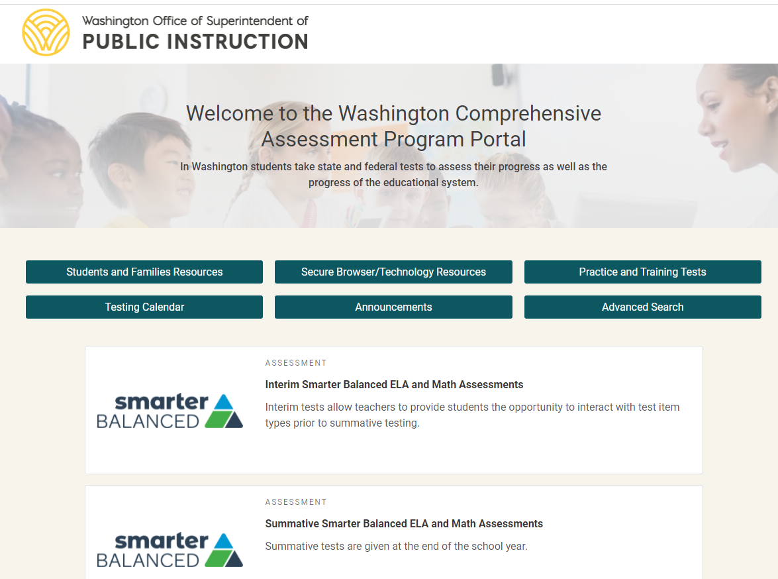
On the WCAP landing page you will see:  Smarter Balanced Interims  Smarter Balanced Summative  WA State Comprehensive Science  Other data such as WIDA and WA Kids | 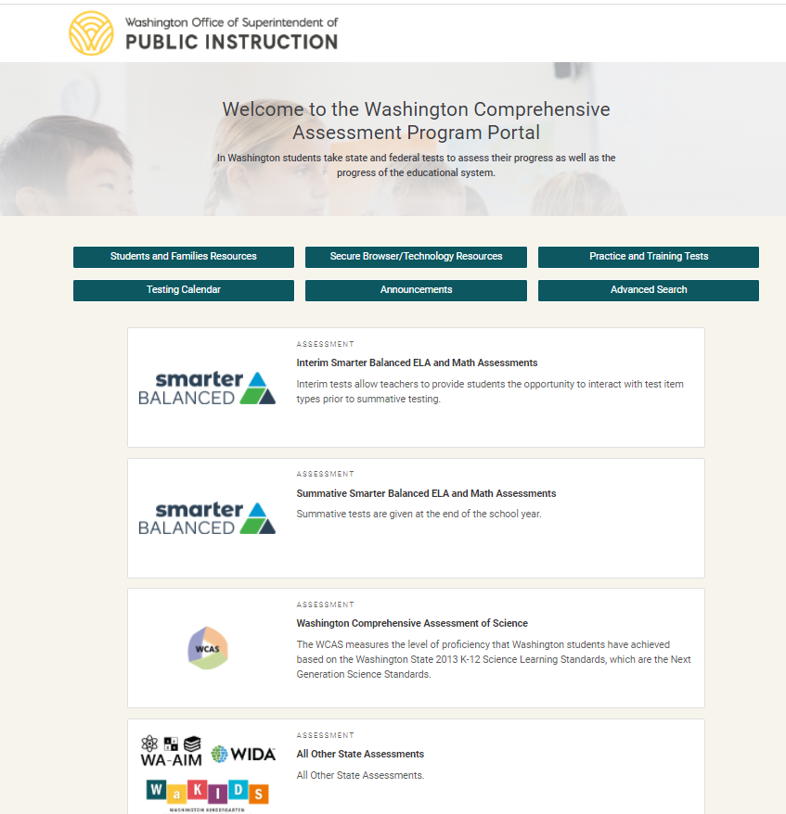
To access and analyze your protected Summative Results at the WCAP landing page, scroll down to the box with the header

Summative Smarter Balanced ELA and Math Assessments

Click on that header

You will now be at the Summative Smarter Balanced ELA and Math Assessments  Landing page  Scroll down to the very bottom to  “After Testing”  and click on that Smarter Summative box | 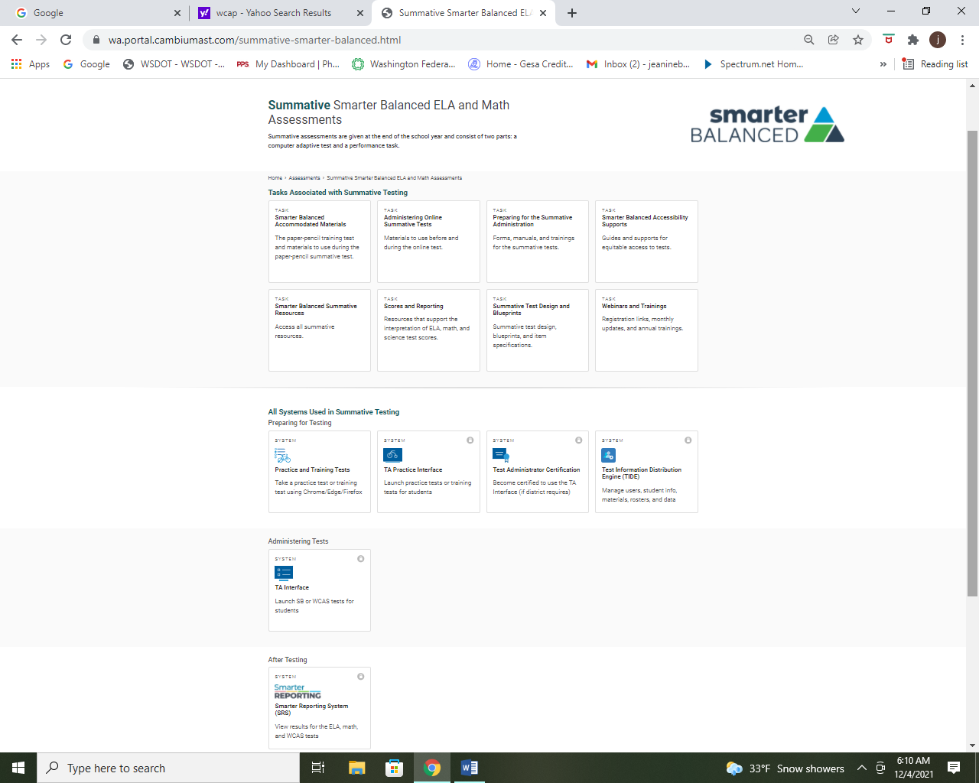
You will be taken to sign in with Log-in and password

If you have not signed in for awhile, you will be sent a code to your email

If that is the case, you will need to enter the code in order to log in

You are now at your Summative Smarter Balanced ELA and Math Assessments  protected students data  Type in the name of the school whose data you want to access and analyze  There will be no data in here until after the spring summative assessment… | 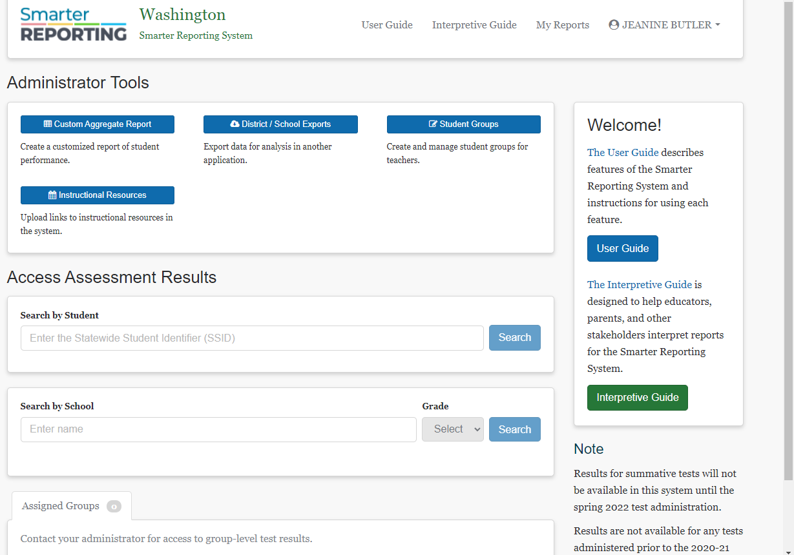
You will first see an overview of the percentage of students who performed at each Level both overall and by Claim (see upper right hand corner arrow).

You can then click on the Select a Results View drop down menu to access and analyze results by students, by writing trait scores or by Target Report.

By choosing the Target Report from the Results View drop down menu you will be able to analyze Levels of student proficiency Target by Target.

You can analyze student performance relative to the entire test or performance relative to Level 3 proficiency.

