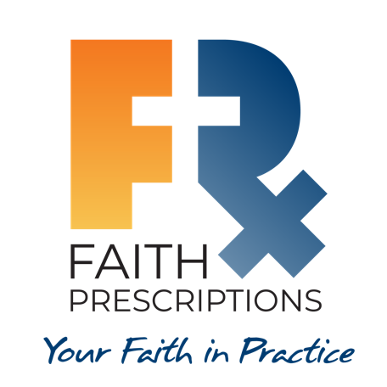
Leader’s Guide

Episode 23
For Educators: Equipping Students and Residents

Summary

It is a great privilege to be able to positively influence the next generation of healthcare professionals. Those who instruct students and residents seek to equip them with the knowledge and the heart to treat patients with skill and compassion. Educators who walk with Jesus are uniquely gifted to speak into the lives of students during their training years. The difficulties encountered during this formative period of instruction can be used by the Lord to create caregivers who promote healing of both body and soul.

Speaker
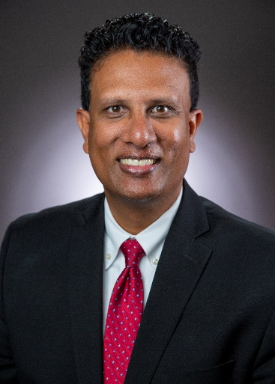
Dr. Francis Nuthalapaty is a maternal-fetal medicine physician and obstetrics and gynecology residency program director at the Northeast Georgia Medical Center in Gainesville, Georgia. He became a committed Christ follower during his fellowship and is sensitive to the power of the gospel in training environments. He and his wife Elizabeth have three children. For further information or to contact Dr. Nuthalapaty, email him at fsn@nuthalapaty.net.

Discussion Questions

- What from this video inspired, edified or challenged you?

- Dr. Nuthalapaty speaks of encountering doctors during his medical school years who “just seemed so unhappy…it seemed like they wanted to be somewhere else, they didn’t enjoy what they were doing.” What are some of the factors that can contribute to our overall career contentment in healthcare? See Colossians 3:23, Psalm 90:17 and 2 Corinthians 4:18.

In order for us to have a degree of contentment in our work, a certain level of competency is necessary. We want to believe patients will benefit from the treatment we provide, and the gratitude they express can be a great encouragement to us. However, we cannot live on the praise of others, as sometimes it is absent, and other times it is more than we deserve. Our higher goal is to honor the Lord in our efforts, seeking to provide excellent care in response to the One who has given us the ability to do so. Even if we are able to provide excellent clinical care to our patients, however, we must practice in light of the fact that these earthly bodies of ours were not meant to last forever. Our approach to patient care is to reflect the fact that each person was created in God’s image (Genesis 1:27) and the fact that each person has a soul that will never die (Matthew 25:46). For these and many other reasons, we seek not just to positively affect our patients’ physical state, but also to communicate the love of God to them in a way that can grow faith in their lives.
- Three simple and practical recommendations are mentioned to help educators engage with healthcare trainees:

  - Be authentic.
  - Make your home a sanctuary.
  - Learn about the students.

How can each of these steps positively affect the personal and professional development of the students?

- Be authentic – As we allow students to see both our faithfulness and our shortcomings, they will see that Christ has made a real difference in our lives, and also that we stand in need of His forgiveness on an ongoing basis.
- Make your home a sanctuary – Students and residents feel pressure from countless different sources during their training years. Their desire to spend time with you will be greatly enhanced if they know they are welcome in your home, without judgment or pressure. In addition, if they are welcome in your home, they will get to see the difference Christ can make in the relationships within a family.
- Learn about the students – As with patients, the more interest you show in the details of your students’ lives, the more loved they will feel. This can help them to be more open to you, leading to a deeper relationship with them.

- Dr. Cathie Scarbrough references how residency is a crucial time when residents might be inclined to either give up their faith, or they can “embrace spiritual care and whole person medicine and run after that for the rest of their careers.”

- What factors could lead to a healthcare student or resident falling away from the Christian faith?

Withdrawal from sources of spiritual nourishment—church, Bible study, etc.—can create distance and indifference in one’s relationship with the Lord. It may also be that some who were part of a church early in life were just going through the motions and may not have possessed life-changing faith. Whatever the reason, it is not surprising that the great demands placed on students and residents can have a negative effect on their spiritual lives.

- Conversely, how might the training years serve as a time of spiritual growth and maturity?

While some might fall away from the Lord during training years—at least for a time—there are others who are humbled by the difficulties they face and end up coming to faith, or growing in faith, because of their challenges. True faith is like muscle tissue in that resistance can bring about increased strength and vitality.

- Dr. Laurie Tam speaks of how those students who participate with their CMDA communities can develop habits during their training to enable them to thrive through residency and beyond. What are some examples of good habits that can assist us in our training years and beyond? (Hint: Dr. Jonathan Tsai mentioned one.)

Regular prayer—especially for others—can help to prevent us from becoming too introspective and selfish. Also, involvement with a group of other Christians can provide the fellowship that God’s people need and cherish. Regular time in the Bible can provide that “two-edged sword” (Hebrews 4:12) that can cut through the subjectivity that at times captures us all.

- Dr. Nuthalapaty shares his wonderful story of a medical student who came to faith in Christ, and dental student Liz Flaherty describes the opportunity students have to plant gospel seeds during their training years. Do you know of anyone who came to faith, or grew in faith, during their professional training? What might contribute to the gospel taking root in the heart of a healthcare student?

During our training years, most of us experience a profound sense of humbling, an awareness that we have much to learn in order to serve our patients well. The longer we practice and the more competent we become, the more confident we can become in our own abilities. For this reason, it seems likely that far more come to faith in Christ as students and residents than at later points in their careers.

- It was a mission trip with CMDA’s Global Health Outreach that introduced Dr. Nuthalapaty to the joy of the gospel. How have your efforts to treat the needy, either domestically or internationally, affected your walk with Jesus?

Serving those with far greater material needs than our own can help us see how tremendously blessed we are. Hopefully, it not only makes us more grateful for what we have but also less dependent on our health or our possessions for our ultimate joy. We can be humbled by the faith of those we serve on the mission field and, thereby, be inspired to use our talents and possessions to point others to Christ.

- What is one take-home item from today’s session that you hope to implement?

Additional Resources

- Living in the Lab Without Smelling Like a Cadaver by William C. Peel, ThM
- Jesus, MD by David Stevens, MD
- What I Learned about God in Medical School by Troy Vines, MD

