Participant’s Guide

Episode 9
Will Our Patients Listen?

Summary

Our ability to care for our patients, both physically and spiritually, will greatly depend upon our ability to truly empathize with their difficulties and struggles. Every person is made in the image of God, and we have opportunities to communicate this truth to our patients in a powerful way. If they recognize our care for their physical condition, they will be more likely to consider what we say regarding what only the Great Physician can do for them.

Speaker
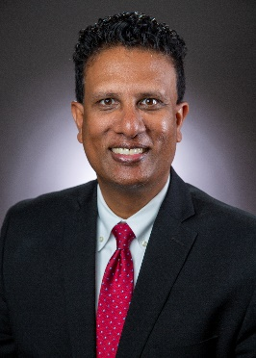
Dr. Francis Nuthalapaty is a Maternal-Fetal Medicine physician and Obstetrics and Gynecology Residency Program Director at the Northeast Georgia Medical Center in Gainesville, GA. He became a committed Christ follower during his fellowship and is sensitive to the power of the Gospel in training environments. He and his wife Elizabeth have three children. For further information or to contact Dr. Nuthalapaty, email him at fsn@nuthalapaty.net.

Discussion Questions

- What from this video inspired, edified, or challenged you?

- Dr. Nuthalapaty’s experience growing up, despite being in a Christian home, left him confused that the way to be right with God was through right performance. Are there any lingering conceptions of faith and practice that remain from your upbringing that affect your view of the gospel today? Do you have examples of how you have moved past incomplete views in the past?

- How did Dr. Nuthalapaty’s recognition of mankind being “fearfully and wonderfully made” influence how he communicated physical imperfections to his patients?

- Has there been a situation in your own life that devastated you, as occurred in the lives of Dr. and Mrs. Nuthalapaty, but now enables you to better empathize with your patients and minister to them? (See Romans 8:18-25, Romans 12:15 and 2 Corinthians 1:3-5.)

- See 2 Corinthians 12:7-10. What does this verse tell us about how God will use our sufferings, weaknesses and imperfections? Why are healthcare professionals hesitant to be vulnerable with patients?

- Dental assistant Harriette Forry illustrates in her video clip the “team” approach to spiritual care for patients, that the love shown by one team member could open the door for a different team member to point patients to Christ. Do you have Christian teammates at your workplace? How can you support each other in communicating the love of Christ to your patients? (See John 17:20-21.)

- Dr. Matt Montgomery shares the following reflection: “I’ve found that both Christian patients and non-Christian patients are anxious to hear what I have to say once I can display to them God’s love in person.”

- Are most of your spiritual patient discussions with Christians or non-Christians?
- What are some similarities and differences regarding these discussions?

- Dr. Krystal Mattox exhorts us towards “caring about our patients enough to know what’s going on in their life.”

- What makes this hard?
- What makes this valuable?

- What is one take-home item from today’s session that you hope to implement?

Additional Resources

- The Practical Art of Spiritual Conversation by Schultz, James Harrison and Rogers, David

