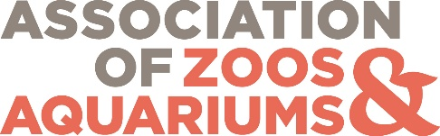
Animal Welfare Committee Open Meeting: Managing and Applying Welfare Assessments to Enhance Wellbeing
1-3 pm EDT, May 13, 2025
AGENDA
Welcome/Introduction – Grace Fuller, Detroit Zoological Society
Recap of AZA Wellbeing Summit – Erika Bauer, AZA
Behavior SAG Update – Kim Leser, Oklahoma City Zoo and Botanical Garden
Animal Welfare Committee Strategic Plan – Grace Fuller, Detroit Zoological Society
Presentations: Welfare Assessment Follow-Up
- Fostering a Culture of Care through Animal Wellbeing Assessments – Katie Vyas, Denver Zoo
- Applying and Refining an Assessment to Improve Rockfish Welfare – Cora Webber, California Academy of Sciences
- Using a Google Drive-Based System to Track Animal Wellbeing Action Plans – Stephanie Norton, Reid Park Zoo
- Assess and You Shall Receive: A Case Study in the Use of Microsoft Apps for Assessment and Action Tracking – Molly McGuire, Toronto Zoo
- Assessing After the Assessment: What Inspectors Are Looking for in Wellbeing Assessment Follow-Ups – Beth Posta, Toledo Zoo

Break-Out Room Discussions
- Training and resource needs related to welfare assessment follow-up (Facilitator: Katie Hall, Minnesota Zoological Garden)
- Addressing technology challenges for assessments and follow-up action (Facilitator: Molly McGuire, Toronto Zoo)
- Strategies for integrating wellbeing assessments into other organizational processes and culture (Facilitators: Tim Van Loan, The Living Desert Zoo and Gardens & Katie Vyas, Denver Zoo)
Report Out and Group Discussion

