PARTICIPANT GUIDE
The Intentional Teacher
Cultivating Child-Centered Discovery, Content-Rich Learning, and Joy

Presenter:
Dr. Amy Schmidtke


Defining Intentional Teaching
“Intentional teachers act purposefully, with knowledge and thought, to make decisions that enhance each child’s learning and development.”
Excerpt: Preface, pp. x–xi

Intentional teaching is grounded in the idea that effective educators act purposefully and thoughtfully to support each child’s learning and development. Rather than relying on routines or chance moments, intentional teachers make informed decisions—drawing on their knowledge of child development, curriculum goals, and what they observe in the moment.

An intentional teacher is both planful and responsive: planning experiences with clear learning purposes while remaining attuned to children’s ideas, interests, and cues. This balance of child-guided exploration and adult-guided instruction allows learning to unfold with both joy and depth.

The table below illustrates what intentional teaching looks and feels like in practice:

Intentional Is… | Intentional Is Not…
- Purposeful — acting on purpose, not by habit  - Responsive — tuned in to children’s cues and questions  - Reflective — thinking before, during, and after teaching  - Curious — observing to learn about children’s thinking  - Joyful — finding delight in discovery and connection  - Flexible — ready to shift plans when children show new interests or understandings  - Evidence-informed — using what we know about development and content  - Balanced — a blend of child-guided and adult-guided experiences  - Culturally aware — connecting to children’s backgrounds and identities”  - Relational — rooted in trust and connection with children  - Clear in purpose — knowing how each activity enhances children’s learning and connects to learning goals  - Playful — seeing play as a context for deep learning | - Accidental — hoping learning happens but not planning for it or assuming it will just happen  - On autopilot — doing what we’ve always done  - Overly scripted — following plans without observing children  - Random — fun or exciting activities without clear learning goals  - Rigid — sticking to a plan even when children lead elsewhere  - Reactive — responding to behavior instead of guiding learning  - Disconnected — activities that don’t build on children’s ideas and current understanding  - Busywork — doing for doing’s sake  - Silent — missing teachable moments because we’re distracted
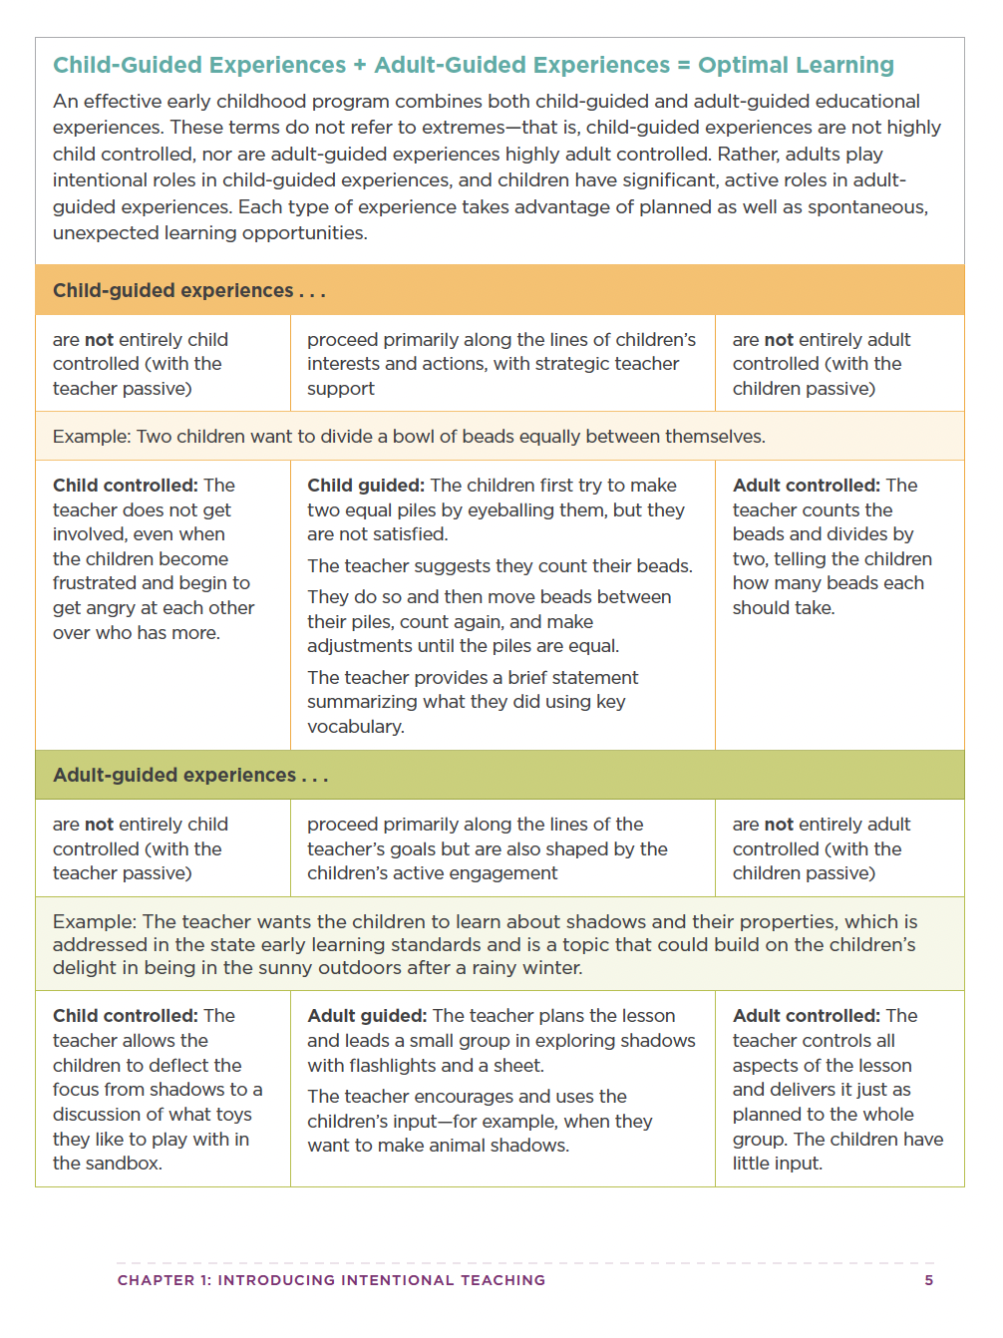
Teaching with Purpose and Joy
“Intentional teaching is as much about delight as direction. It’s about knowing what matters most and finding joy in how children get there.” Excerpt: Chapter 1, Introducing Intentional Teaching p. 11

Instructions for Participants: Reflect independently and write your responses to the following questions:

🌱 Fostering Child-Guided Experiences
How can I create space for children’s curiosity and ideas to lead learning?

🧩 Making Intentional Adult-Guided Moves
How can I extend children’s thinking and connect exploration to deeper content?

✨ Prioritizing Joy and Wonder
How can I keep joy, connection, and curiosity at the heart of teaching and learning?

