Participant’s Guide

Episode 15

Not For Dentists Only

Summary

Those fortunate enough to be practice owners have a tremendous opportunity to direct every aspect of their practice according to the timeless wisdom of the Scriptures. Although fewer and fewer doctors own their own practices than in prior times, the many spiritual advantages are worth serious consideration in our prayerful determination of the best practice setting for us.

Speaker

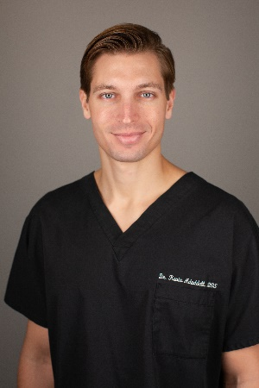
Dr. Kevin Aduddell is a private practice general dentist in Plano, Texas. A member of CMDA since dental school, he has treated patients from countries around the world at Watermark Urgent Care in Dallas, Texas. He and his wife Chloé stay busy with their three children and serve together in their church’s marriage ministry. For further information or to contact Dr. Aduddell, email him at kevin@aduddelldentistry.com.

Discussion Questions

- What from this video inspired, edified or challenged you?

- What fears or apprehensions do you have about leading a Christ-centered office?

- Dr. Aduddell mentions Galatians 2:20 in his initial comments. How might the concepts of being crucified with Christ and letting Christ live His life through you change your practice? Be specific.

- Dr. Aduddell mentions that idols in our lives can keep us from making our practices Christ-centered (profitability, false sense of professionalism, complacency to the call of Christ, etc.). Which of these or other idols most strongly tempt you?

- Consider 1 Peter 3:15.

- How does this verse speak to the topic of idols?

- As we are enabled by faith to say no to idols and yes to Christ, what could happen according to this verse?

- Dr. Aduddell says, “‘Doctors don’t pray’ is just pride wearing a white coat.” What are your thoughts?

- Why can it be spiritually dangerous if we treat patients with excellence and compassion but refuse to acknowledge the Lord along the way?

- Dr. Aduddell discusses several ideas to help make a practice Christ-centered: praying over your schedule, using faith flags, dealing with conflicts biblically and stepping into a patient’s pain. Which of these strategies do you employ currently or would like to employ in your practice?

- Drs. Huong, Allen and Griffin give examples of how owning one’s practice can open the door to some profound spiritual opportunities. If you own your practice, what are some ways you could utilize this benefit to bless both your employees and your patients?

- Who do you have in your life that could regularly encourage you to persevere in your desire to have a Christ-centered practice? Why is this important?

- Take some time and imagine looking back on your practice at the end of your career. What “fruits” will you want to see?

- What is one take-home item from today’s session that you hope to implement?

