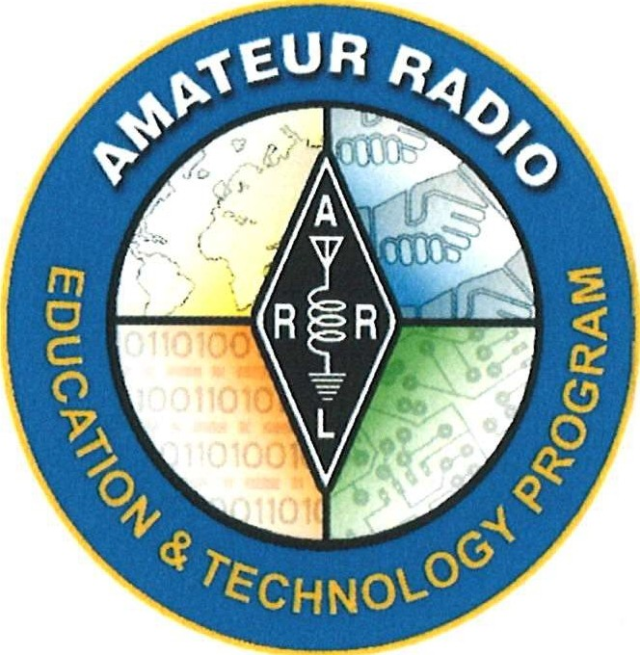

Electronics Curriculum Prepared for ARRL Education & Technology Program Grade Level: 6 - 8

Revised Draft
June 2023

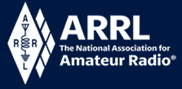

Electronics Course Table of Contents
Day 1 | Intro to Electronics | Where are electronics used today?  Difference between electricity and electronics  Magnet Drop Demo etc.
Day 2 | Direct Current and  DC Circuits | Voltage and Current  (Intro VOM, measure batteries)  Electricity and Magnetism (Monopolar Motor)
Day 3 | Capacitors and Inductors | (Est. 2 day lesson)
Day 4 | Measure Current Electrical Circuits
Day 5 | Measure Resistance Electrical Circuit | Build Series and Parallel Circuits  (Est. 2 day lesson)
Day 6 & 7 | Ohms Law
Day 8 | Introduction to Circuit Boards - Soldering 101 | Symbols, markings & construction  Start build…
Day 9 | Build a Clock Kit or Other Electronics Kit | …Complete build  Test and repairs
Day 10 | Alternating Current | Frequency, Period and Examples of AC Voltages
Day 11 | Amplifiers | Compare different waveforms
Day 12 | Oscillators
Day 13 | Diodes
Day 14 | Rectifiers
Day 15 | Transistors

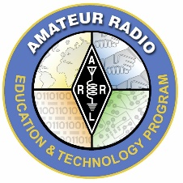 | Title of Lesson: Amplifiers (Day 11)  Grade Level: 6th - 8th Grade
Electronics Curriculum Prepared for ARRL Education & Technology Program
Updated June 2023

Core Components
Subject, Content Area or Topic:
Physics, Electronics, Science, Math
Next Generation Science Standards (NGSS): (Assign as needed based on your state standards)
MS.PS4.A Wave Properties - A simple wave has a repeating pattern with a specific wavelength, frequency, and amplitude.
MS.PS4.3 Technologies extend the measurement, exploration, modeling, and computational capacity of scientific investigations.
Systems and System Models Models can be used to represent systems and their interactions- such as inputs, processes and outputs- and energy and matter flows within systems. (MS-PS2-1),(MS-PS2-4)
Common Core State Standards for Mathematics: (Assign as needed based on your state standards and grade level)
7.EE.4a Solve real-life and mathematical problems using numerical and algebraic expressions and equations.
Common Core State Standards for English Language arts & Literacy in History/Social Studies, Science, and Technical Subjects: (Assign as needed based on your state standards and grade level)
Vocabulary acquisition and Use Standard 6: Acquire and use accurately grade-appropriate general academic and domain-specific words and phrases; gather vocabulary knowledge when considering a word or phrase important to comprehension or expression.
CCSS.ELA-Literacy.SL.6-8.1 Engage effectively in a range of collaborative discussions (one-on-one, in groups, and teacher-led) with diverse partners on grade level topics, texts, and issues, building on others’ ideas and expressing their own clearly.
College and Career Readiness (CCR) Anchor Standards:
CCR.10 Write routinely over extended time frames (time for research, reflection, and revision) and shorter time frames (a single sitting or a day or two) for a range of discipline-specific tasks, purposes, and audiences.
Vocabulary: (Add as needed based on your learning requirements)
Review with the students the vocabulary needed to describe a waveform (See list in Preparation section)
- Valve | - Channel | - Factor
Learning Objectives: (What will the students learn and demonstrate?)
Students will discover simple amplifiers. Students were experiment, measure and compare different waveforms. Students will reflect on their experiment and answer critical thinking questions in written form (See the assessment section for this objective)

Materials/Resources:
- Voltmeter  - Oscilloscope | - The 5 Building Blocks demonstration board or a circuit board of your choice
Safety: (if applicable)
Discuss electrical safety.
Prerequisite Understanding:
- Volt/Ohm meter
- PropScope
- Ability to follow step-by-step procedural instructions.

Process
Anticipatory Set: The Hook (This is something that will get your students excited about the subject.)
Bring or borrow an acoustic guitar and amplifier to bring into the classroom. Find someone who can play guitar or at least a few notes consistently. Play the acoustic guitar for the class with the amplifier disconnected. Next, connect the amplifier to the guitar. Now, play the same tune.

Ask: “What was the difference between the first second?”
Explain: An amplifier, or amp, is an essential component used to take a weak signal and increase it to become a stronger signal.
Instructional Input or Procedure (Input, modeling, and checking for understanding)
Preparation:
Review with the students the properties of AC. Review with the students the vocabulary needed to describe a waveform (wavelength, frequency, cycle, crests, trough, positive side, negative side amplitude).

Explain to student the relationship between amplitude and the strength of a wave. Ensure that students understand amplification modifies the strength (amplitude) of the wave, but does not change any other property of the wave (shape, frequency, etc.).

A good analogy to explain the concept of amplification is to use a sink water valve as an example. The purpose of a sink water valve is to control the flow of water into the sink. A small force to turn the valve open causes the flow of water to increase; an opposite turn causes the flow to decrease. If the students were to try and control the flow of water, under full pressure, with their thumbs they would spray lots of water.

In an amplifier, small voltages are applied to the input of the circuit to cause an increased flow of current (at higher voltages and currents) on the output and vice versa. A string of amplifiers connected in series can allow incredibly small current to replicate themselves as extremely large currents. The analogy to the valve is so good that the British refer to transistors and vacuum tubes, the primary component of an amplifier circuit, as valves. (McCray & Spencer, 2016)
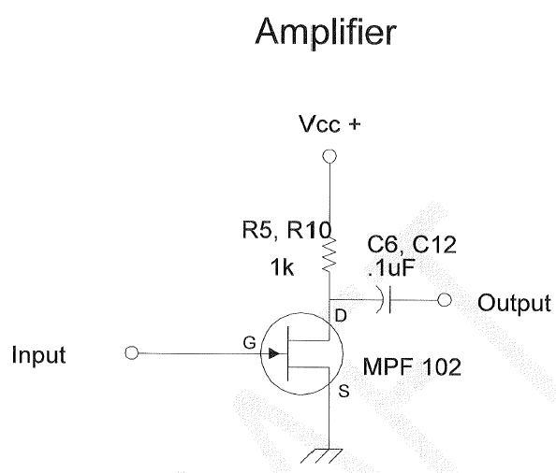
Guided Practice: What to do and how to do it
Teaching Tip: Model how to set up the oscilloscope with the five building blocks circuit board. Then have your students do the same.
- Connect one channel of the oscilloscope to the output of one of the oscillators. Students should note the peak voltage of the waveform produced by the oscillator. They should also note the wave shape and frequency for later comparison to the amplified wave.
- Connect the oscillator to the input of the amplifier and connect the second channel of the oscilloscope to the output of the amplifier. Task students to note the peak voltage of the waveform on the output of the amplifier. They should also note the wave shape and frequency of the output waveform.
- Vary the amplitude of the input waveform and observe the resulting output of the amplifier.
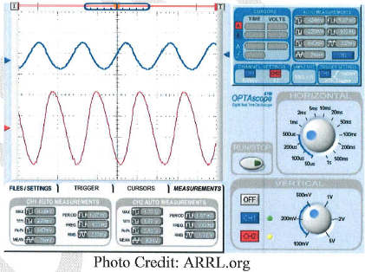
- Have students share their observations with the rest of the class.

More Information on the Oscilloscope Image Above: The example shown is taken from an Oscilloscope, not a PropScope. However, they both demonstrate the wave in the same way. The upper trace is the input to the amplifier. The scale of that trace is 500 MV. The lower trace is the output of the amplifier. The scale of that trace is 1V. Visual inspection of the traces reveals that the amplifier increases the signal by a factor of 5.4.
Independent Practice:
- Instruct students how compare the input to the output waveforms (compare frequency, wavelength, and amplitude).
- Have students change voltages to see a difference in waveforms.
- Students will calculate the gain, or amount of amplification, which was achieved by the amplifier.

Assessment/Closure
Assessment (Pre, post etc…)
Assign students any combination of these questions to answer in short response. Students can share in the next class via a full class discussion or a jigsaw group share if desired.
- How did you calculate the gain of the amplifier? In your own words, define gain.
- Do you think there is a limit to the amount of amplification possible? If so, what would cause that limit?
- What happens if you turn your amplifier at home too high? Are there any precautions listed on your home amplifier? If so, why do they have these precautions?
- Many communities have or are considering city ordinances restricting the use of amplifiers. What is the motivation for these restrictive laws? How do you feel about the government limiting your use of amplifier? Why? Can you offer an alternative?

- Assignment: Understanding Basic Electronics Unit 1, Pages 4-5: “Oscillators”
Ham Radio Connection: Fire up a ham radio of your choice. Adjust the gain up and down. Discuss the effects of too much or too little gain.
Resources:
- Understanding Basic Electronics
- http://www.arrl.org/files/file/ETP/The%205%20Building%20Blocks%20activity%20board%2023.pdf
- https://www.nextgenscience.org/overview-dci

Bibliography:
McCray, N. (2016, August 11). ARRL. Retrieved from ARRL The National Association for Amateur Radio: http://wwwarrl.org/lesson-ideas-basic-electronics
https://learning.ccsso.org/wp-content/uploads/2022/11/ADA-Compliant-ELA-Standards.pdf
https://learning.ccsso.org/wp-content/uploads/2022/11/ADA-Compliant-Math-Standards.pdf
https://www.nextgenscience.org/sites/default/files/MSDCI.pdf

