Introduction to the School Leader Paradigm

Why does School Leadership falter? Is it more about what the leader DOES or
WHO they are?
Thoughts/Reflections:

Leadership is an art, a delicate balance between “becoming while doing”.
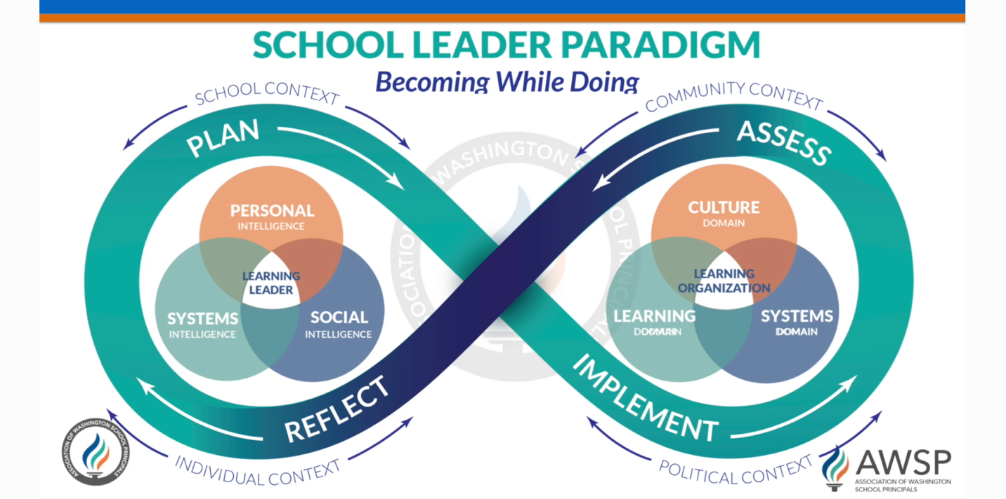

Can you use the paradigm to help you remember your own leadership journey? Your own becoming while doing development as a school leader?
Thoughts/Reflections:

What kind of building leader should a district be looking to hire for a school that has had four principals in six years?
Thoughts/Reflections:

What should a district be considering when hiring for the new principal after the beloved 20 year veteran principal is retiring?
Thoughts/Reflections:

What kind of leader does a school need that’s done a great job of keeping everyone happy, but haven’t changed systems for over a decade?
Thoughts/Reflections:

